A Project Report on
Social Networking

Submitted By

Altaf Shaikh

Year 2010-2011

Under Guidance of
Prof. Shubhangi Pawar

In partial fulfillment of the requirement for quaifying
Bsc (I.T.) Semester VI Examination



Western College of Commerce &
Business Management
Sanpada, Navi Mumbai 400 705

Vishweshwar Education Society’s
Western College of Commerce &
Business Management
Plot No.2, Sector-9, Sanpada, Navi Mumbai 400 705

Affliated to University of Mumbai

CERTIFICATE

This is to certify that Project entitled _____________________________________
Undertaken at the _______________________________________________________
by Mr.____________________________ Seat No. _____________
in partial fulfillment of B.Sc (Information Technology) degree
Semester VI Examination as syllabus of the University of Mumbai for academic year 2009-2010. It is further certified that she has completed all required phases of the Project.

Signature of Internal Guide Signature of HOD/Coordinator

College Seal

Signature of External Guide Signature of Internal Examiner

Preface

The project “Social Networking” is a way which allows facilitating communication, collaboration, and content sharing across networks of contacts. I have developed this project in PHP and MySQL, which are the effective web development tool and an open source.

In this project, all the operation is carried out between the server and client machine. In existing systems the features like emails, blogs, chat, etc are provided by different sites. Thus, it becomes difficult for the user to use all these features at a time in the existing system. I have successfully tried to eliminate such problems and drawbacks of the existing system. This report provides the brief idea of how this web site was created and how to use it.

Making it user friendly was my main ideal while developing the system. Here I take the privilege of introducing the project.

Acknowledgement

It is with great pleasure that I present my first venture in real life application of computing in the form of project work. It has proved very helpful with respect to program developing techniques. I acknowledge my sincere gratitude to all those who helped me to make this project a success.

First, I extend my sincere thanks to the Principal Dr. Arvind Burungale and my guide & faculty Prof. Shubhangi Pawar for their co-operation and guidance throughout the course and briefed me from time to time a normal support and overcoming my anxiety to perform in this project.

I express my gratitude to all the faculty members of IT department who turned my knowledge in field of IT in the real world. I also thank those who helped me directly or indirectly during my project.

I would also like to thank the computer laboratory staff for allowing me to use computers, internets and print facility at all times.

Last but not least I would like to thank to my family and friends for their constant moral support.

INDEX

SR. NO. | CONTENTS | PAGE NO.
 | OVERVIEW | 7
 | SYNOPSIS | 8
1 | ANALYSIS PHASE | 12
 | - SITE SPECIFICATION | 12
 | - ABOUT THE WEBSITE | 12
 | - OBJECTIVES OF THE SITE | 12
 | - SCOPE OF THE SITE | 13
 | - USER OF THE SITE  1.TYPES OF USERS | 13
 | - URL | 14
 | - FEASIBILITY STUDY | 16
 | - OPERATIONAL | 16
 | - TECHNICAL | 17
 | - ECONOMICAL | 17
 | - REQUIREMENT SPECIFICATION | 18
 | - HARDWARE AND SOFTWARE TREQUIREMNET | 18
 | - PROJECT SCHEDULE | 19
 | - GNATT CHART | 19
 | - PERT | 20
 | - TOOLS AND TECHNOLOGIES USED | 21
 | - DEVELOPMENT METHODOLOGY | 26
2 | DESIGN PHASE | 28
 | - E-R DIAGRAM | 28
 | - INFORMATION STRUCTURE | 29
 | - SYSTEM FLOWCHART | 30
 | - SITEMAP | 53
3 | IMPLIMENTATION PHASE | 54
 | - CODING
 | - SCREEN LAYOUT
4 | PUBLISHING THE WEBSITE | 132
 | - UPLOADING TECHINQUES | 132
5 | TESTING | 134
 | - TESTING CONSIDERATIONS | 134
 | - VARIOUS TYPES OF TESTING | 134
6 | MAINTAINANCE OF THE WEBSITE | 138
7 | FAQ’S (ONLINE USER MANUAL) | 139
8 | FUTURE ENHANCEMENTS | 141
9 | ANNEXURE | 142
 | - DATA DICTIONARY | 142
 | - LIST OF ABBREVATIONS | 147
 | - REFERENCES | 148

OVERVIEW

Social Networking Sites allow users to manage, build and represent their social networks online. They are usually (but not always) made up of other individuals; they might also include the profiles of events, companies, even political parties.

They may let you add anyone in the network as your "friend" or contact, or they might ask for all connections to be agreed by both parties. They typically support the public display of networks - although they may offer privacy restrictions, or facilitate closed communities.

Social networking sites are often perceived by their users as closed environments, where members talk to other members.

SYNOPSIS

- INTRODUCTION

Social Networking Services (SNS) are changing the ways in which people use and engage with the internet and with each other. Young people particularly are quick to use the new technology in ways which increasingly blur the boundaries between their online and offline activities.

Social networking services are also developing rapidly as technology changes with new mobile dimensions and features. Children and young people, who have grown up taking the internet and mobile technologies for granted, make up a significant segment of “the beta generation”, - the first to exploit positive opportunities and benefits of new and emerging services, but also the first to have to negotiate appropriate behaviors within new communities, and to have to identify and manage risk.

Social Networking Sites allow users to manage, build and represent their social networks online. They are usually (but not always) made up of other individuals; they might also include the profiles of events, companies, even political parties. They may let you add anyone in the network as your "friend" or contact, or they might ask for all connections to be agreed by both parties. They typically support the public display of networks - although they may offer privacy restrictions, or facilitate closed communities.

2. Need of Social Networking

Loneliness is being cited as causing low-grade peripheral inflammation which, in turn, is linked to inflammatory diseases such as diabetes, cardiovascular disease, and autoimmune disorders (e.g. rheumatoid arthritis, lupus).Lack of social connection or loneliness is also associated with increased risk of cardiovascular disease. Loneliness is found to be a unique predictor of age-related differences in systolic blood pressure.
The modern lifestyle is so hectic that it has become difficult to maintain social relationships by personally visiting friends and relatives. However, this does not mean that you cannot interact with them or have to stop all kinds of socializing as the modern technological developments has provided the facility of sitting at home and maintaining the social relations with the help of the computer and the internet. The social networking sites have become the ideal source of social media that not only helps you to keep in touch with the people you know but also gives you the opportunity to develop new acquaintances with the help of this social network. Businesspersons who are engaged in online business have realized the importance of this online social media as they have accepted the fact that the social network sites are the best place for the promotion of their service and products if they want to flourish their online business.
Thus, to help people to interact with their friend or make friends.And also to help the bussiness men to sale their product I am providing Social Networking Service to them through my website.

3. Real World Application

Social networking platforms give nonprofits a forum for meeting like-minded organizations and potential supporters, and provide a medium for spreading their messages beyond the immediate community.

While many people regard social networking tools as a fun diversion, some nonprofits are leveraging them to accomplish serious goals, such as increasing their visibility, helping constituents find jobs, and raising awareness about time-sensitive issues.

We can use SNS to help the users to clear their doubts. And also make the people aware by providing any social cause information. It has not taken long for social networking sites to become prevalent amongst the youth.

I am also including the feature like to block any user who does abusive things on my website.

4. Features and Benefits of Social Networking Websites

Most social networking websites are supported by paid advertisements that appear on member pages. Because of this, most social networking websites do not carry membership charges and offer free services to all users. What does that mean? The features and benefits of social networking websites are available to companies with any budget!

Share-
Feature: Personal profiles. Create and customize a profile with certain content such as name, location, interests, website links, and more.
Benefit: Share your story, success, services and products with the community on your social networking website.

Show-
Feature: Personal user image. Upload a user image to represent you on the social networking website.
Benefit: The social community can put a face with your name, and come to recognize you based on your familiar avatar.

Socialize-
Feature: Communicate with text-based comments. Many social networks allow you to communicate with friends either by private e-mail-like correspondence, public message board-like posts, or both.
Benefit: Stay in touch with contacts, reach out to new people, and show the community you care about company-to-client communication!

The Goal of Social Networking Websites
Social networking websites are designed to allow members to connect and communicate with one another - so features of these sites foster interaction, activity, and of course, community.

ANALYSIS PHASE

A) SITE SPECIFICATION

- ABOUT THE SITE

As we know that, a social network service focuses on building and reflecting of social networks or social relations among people, e.g., who share interests and/or activities. A social network service essentially consists of a representation of each user (often a profile), his/her social links, and a variety of additional services. Thus, using my project I am providing such services to my users so that they can enjoy those services in a single site i.e. “MeetUp”.

Throughout my project users can:
  - make their profile,
  - search for their friends,
  - checkout their(friends/users) profile,
  - add them(users) in their friends(contact) list,
  - they can Private Message each other,
  - comment into their profile,
  - share their photos,
  - Block unwanted users from watching/interacting with them.

- OBJECTIVES OF THE SITE

- This website is developed for convenience of all the users.
- It provides complete flexibility for users to share information with their friends.
- The users can remain in touch with their friends all the time.
- The users can find their old friends.

3. SCOPE OF THE SITE

To overcome the limitations of the current system and to increase the working efficiency of the system, I decided to include all features together in single system. The main aim of my proposed system was to allow the users to enjoy all the activities like commenting, private messaging, albums, etc in one single system.

4. USERS OF THE SITE

A) TYPES OF USERS:

NATÏVE USERS:

These are users who visit the site just for merely gathering information. These users are those who lack programming language. These kinds of users are very large in number as net surfing is the popular hobby of the people around these days.

FREQUENT USERS:

These users have some knowledge about the sites so they visit frequently with the urge to know something new or keep themselves abreast of the latest happenings and updates rushing in from their friends.
E.g. Registered Users

POWER USERS:

These are those users who actually handle the site for the purpose for which it has been designed for. These people have a very good knowledge about the website and its programming can fulfill the requirements that are to be fulfilled by the professional users.
E.g. Admin

5. URL
Uniform Resource Locator (URL), locates the document to be retrieved when a user clicks on hyper text links. URL is similar to file name expect that, in this case, the file can be on the same machine or a different machine on the network.

In its current strict technical meaning, a URL is a URL (Uniform Resource Identifier) that, in addition to identifying a resource, provides a means of locating the resource by describing its primary access mechanism.

The file retrieval methods vary, depending on the type of the document to be retrieved. A URL needs always points to a document but can also point to a query, image or the result of command.

It is the reference address of the document used on the internet.
URL must be specific. URLs are typically entered into the address or location bar of a web browser.

Hypertext Transfer Protocol (HTTP) is a communications protocol used to transfer or convey information on the World Wide Web. Its original purpose was to provide a way to publish and retrieve HTML hypertext pages.

The URL describes where something is and how it will be retrieved. The how is specified by the protocol for example, HTTP. The where is specified by the machine name, the directory name, and the filename. Slashes and other characters are used to separate the parts of the address into machine-readable pieces. The basic structure of URL is:
Protocol: //site address/directory/filename

A Client who wants to access a document needs an address. To facilitate the access of documents throughout the world, HTTP uses the concept of Locators.

The Uniform Resource Locator (URL) is a standard for specifying any kind of information on the Internet.
The URL defines four things:
- Methods
- Host
- Computer port and
- Path.

The methods are nothing but the protocol what it uses to retrieve the information.

The host is the computer where the information is located, although the name of the computer can be alias web pages are usually begins with “www”. This is not mandatory, however as the host can be any name given to the computer they host the web page.

The URL optionally can contain the port number of the server. If the port is included, it should be inserted between the host and path, and it should be separated from the host by colon like

http://www.meetup.co.cc

Path is the pathname of the file where the information is located. The path can itself contain slashes that are used to separate the directories from the subdirectories and files.

The proposed url for this website constructed for remaining in touch with your friends and other contacts:
http://localhost/

B) FEASIBILITY STUDY

Feasibility study is an activity that verifies whether a project can be started and successfully completed. Is the process by which feasibility is measure? The objective of assessing feasibility is to determine whether a development project has a reasonable chance of success. It is the process of selecting the best system that meets the following requirements i.e.:
The user has recognized a need.
User requirements are determined and the problem has been defined.
An initial investigation is launched to study the existing system and verify the problem.

The analyst has verified the objective constraints and required output.

OPERATIONAL FEASIBILITY

- It is a measure of how well the solution will work in the organization.
- It is a measure of how people feel about the system.
- It measures the urgency of the problem or acceptability of a solution.

There are two aspects of operational feasibility to be considered:
- Is the problem worth solving?
- How do the end user and management feel about the problem?

As the website provides the information which are self explanatory, the user finds that the site will be operationally feasible. The problem statement and the solution steps are designed in a very easy way by following user oriented interfaces.

TECHNICAL FEASIBILITY

A new system brings a new technology into a company.
As the system is dynamic, the flow of data will be done automatically with the help of MySQL queries.
Updates to the site will be done as and when required by the administrators.

Technical Feasibility looks at what practical and reasonable. It addresses three major issues-
- Is the proposed technology practical?
- Do we currently possess the necessary technology?
- Do we have expertise and is the schedule reasonable?

ECONOMICAL FEASIBILITY

Economical feasibility is a measure of the cost effectiveness of a project or a solution.
I am using PHP and MySQL which are provided by most of the Companies around the world for a low cost. There is currently no need of investment of money as there are companies which provide free hosting too which have a good reputation and a good service. More likely if the cost increases then AD Blocks on the site will help me procure it.

COST BENEFIT ANALYSIS

- Open source application are used
- Free premium hosting (sponsered by frenzi)
- Free domain hosting

C) REQUIREMENT SPECIFICATION

Hardware And Software Requirement

The hardware and software requirements from user point of view for the website are:-

Minimum Hardware Requirement:-
FOR SERVER:-
- COMPUTER: INTEL PENTIUM OR COMPATIBLE, 550 MHZ OR HIGHER
- MEMORY: 256 MB (512 MB RECOMMENDED)
- 100MB HARD DISK SPACE

FOR CLIENT:-
- COMPUTER: INTEL PENTIUM OR COMPATIBLE, 550 MHZ OR HIGHER
- 64 MB RAM (RECOMMENDED: 128 MB RAM OR GREATER)
- 52 MB HARD DISK SPACE

Minimum Software Requirement:-

FOR SERVER:-
- APACHE 1.3.X (2.0.63 RECOMMENDED)
- PHP 4.3.2 OR HIGHER (PHP 4.4.X FOR OPTIMAL PERFORMANCE)
- MYSQL 3.2.X OR HIGHER

FOR CLIENT:-
- WEB BROWSER

PROJECT SCHEDULE
1. GANTT CHART
Planned Time

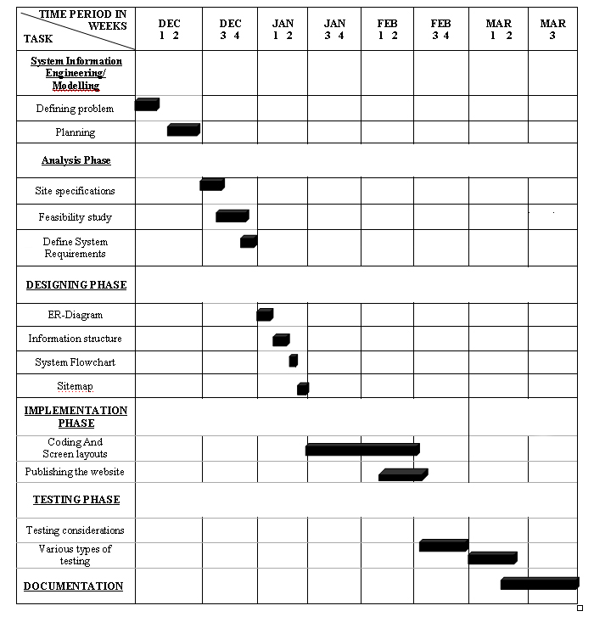

2. PERT Network Diagram

Site specification

(9)
Feasibility study
Design
Planning
Start
(11)
(8)
(14)

Requirements

(3)

Publish
(6)
Implementation
Documentation
Stop
(10)
(55)
Testing
(12)

TOOLS AND TECHNOLOGIES USED

The following software technologies used exhaustively in the site are:

SOFTWARES:

1. Web Browser:

The Web Browser is the software that accesses the web pages from the server. The server responses the web pages in the form of the HTML pages.

2. Web Server:

A web server can be referred to as software that manages web pages and makes them available to the client’s computer via a local network or through the Internet. In case of the Internet, the web server and the browser are usually on two different machines, probably many miles apart. However, in more local situation, we might set up a machine that runs the web server software, and then use a browser on the same machine to look at its web pages.

TOOLS:

Text Editor:
The features in Text Editor, makes it easier to design pages, improve site and asset management, allows one to create HTML pages and also editing of number of documents becomes easier using Notepad.

TECHNOLOGIES:

- HTML (Hypertext Markup Language):
HTML is used to create a document a web page. HTML is open non – proprietary, cross platform compatible language. HTML means Hyper Text Mark-up Language. Hyper Text is used to link information on related topics over the internet.
Hyper text is non liner way of organizing information. Jumping from one related topic to another and quickly finding information and returning to starting point or moving onto some other topic.
A Mark-Up Language is a structure that’s lets you identify common section of a document such as heading, paragraph and list.

- PHP(Hypertext PreProcessor)

PHP: Hypertext Preprocessor is a widely used, general-purpose scripting language that was originally designed for web development to produce dynamic web pages. For this purpose, PHP code is embedded into the HTML source document and interpreted by a web server with a PHP processor module, which generates the web page document.
As a general-purpose programming language, PHP code is processed by an interpreter application in command-line mode performing desired operating system operations and producing program output on its standard output channel.
It may also function as a graphical application. PHP is available as a processor for most modern web servers and as standalone interpreter on most operating systems and computing platforms.

- MySQL

MySQL is primarily an RDBMS and therefore ships with no GUI tools to administer MySQL databases or manage data contained within. Users may use the included command-line tools,[14] or download MySQL Frontends from various parties that have developed desktop software and web applications to manage MySQL databases, build database structure, and work with data records.

The official MySQL Workbench is a free integrated environment developed by MySQL AB, that enables users to graphically administer MySQL databases and visually design database structure. MySQL Workbench replaces the previous package of software, MySQL GUI Tools. Similar to other third-party packages but still considered the authoritative MySQL frontend, MySQL Workbench lets users manage the following:

* Database design & modeling
* SQL development — replacing MySQL Query Browser
* Database administration — replacing MySQL Administrator

MySQL Workbench is available in two editions, the regular free and open source Community Edition which may be downloaded from the MySQL website, and the proprietary Standard Edition which extends and improves the feature set of the Community Edition.

Advantages of PHP & MySQL Technology:

PHP and MySQL are the popular pair for building dynamic Web applications. PHP is a scripting language designed specially for use on the Web, with features that make Web design and programming easier. MySQL is a fast, easy-to-use RDMS (Relational Database Management System) used on many Web sites. MySQL and PHP as a pair have several advantages:

They’re free. It’s hard to beat free for cost-effectiveness.

They’re Web oriented. Both were designed specifically for use on Web sites. Both have a set of features focused on building dynamic Web sites.

They’re easy to use. Both were designed to get a Web site up quickly.

They’re fast. Both were designed with speed as a major goal. Together they provide one of the fastest ways to deliver dynamic Web pages to users.

They communicate well with one another. PHP has a built-in feature for communicating with MySQL. You don’t need to know the technical details; just leave it to PHP.

A wide base of support is available for both. Both have large user bases. Because they’re often used as a pair, they often have the same user base. Many people are available to help, including people on e-mail discussion lists who have experience using MySQL and PHP together.

Web server:

A web server can be referred to as software that manages web pages and makes them available to the client’s computer via a local network or through the internet. In case of the internet, the web server and the browser are usually on two different machines, probably many miles apart. However, in more local situation, we might set up a machine that runs the web server software, and then use a browser on the same machine to look at its web pages.
I used Vertrigoserv while developing this project. It has the following features and benefits:
VertrigoServ has been developed as a highly professional, easy to install package consisting of Apache (HTTP web server), PHP (reflective programming language), MySQL (multithreaded, multi-user, SQL Database Management System), SQLite (ACID-compliant relational database management system), SQLiteManager (multilingual web based tool to manage SQLite database), PhpMyAdmin (tool written in PHP intended to handle the administration of MySQL) and Zend Optimizer (which increases runtime performance up to 40%) for Windows platform. With a convenient all-in-one installer, all components are installed in a single directory and can be used immediately after the installation process has completed. An uninstaller allows you to remove the VertrigoServ from hard disc. It is designed to be as small and flexible as possible and is therefore highly suitable for internet distribution.
VertrigoServ is excellent both for beginners and for advanced users.
- small size (LZMA compressor)
- secure because it contains the up-to-date packages versions
- very to install and use
- no configuration and no manual installation required
- compatible with all major Windows versions
- completely free for any use

DEVELOPMENT METHODOLOGY
Incremental Model

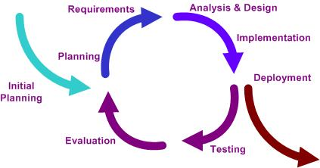

EXPLAINATION
The incremental build model is a method of software development where the model is designed, implemented and tested incrementally (a little more is added each time) until the product is finished. It involves both development and maintenance. The product is defined as finished when it satisfies all of its requirements.

The basic idea behind iterative enhancement is to develop a software system incrementally, allowing the developer to take advantage of what was being learned during the development of earlier, incremental, deliverable versions of the system.

Learning comes from both the development and use of the system, where possible key steps in the process are to start with a simple implementation of a subset of the software requirements and iteratively enhance the evolving sequence of versions until the full system is implemented. After each iteration, design modifications are made and new functional capabilities are added.

E-R Diagram
DESIGN PHASE

Attribute
Relation Ship

Entities
Profile_Id
Profile_Id
M: Many
Level
1: One
Send/
Recieve
Friend Request
1
M
E-Mail Id
Contain
Have
First Name
Member
List
1
1
l
Profile_Id
1
1
Users
Last Name
Password
Have
Has
Have
Have
Profile_Id
About me
Language
Relation_
Status
Phone no
Religion
DOB
Album
Location
Profile
Send
Inbox
Msg Id
Private
Message
Report
1
1
1
1
M
M
M

1

M
Id
Comment

User name
User Id
Reason
From Id
Date
Reported by
Time
Content
Have
Admin
Date
From
Reason
User
Warning
Update Profile
Delete Profile
1
M
Login Id

Information Structure

Web site is built basic structural themes. These fundamental architectures govern the navigational interface of the web site and mold the use’s mental models of how the information is organized. Five essential structures can be used to build a web site:

Linear: It’s the type of sequential flow of the website.

Tutorial: it consists of the sub topics as chapters.

Web: It is the website which can return to home page at any time.

Hierarchical: It consists of a main page which can link to any of the pages.

Cluster: It is structure of both web and hierarchical structure.

Catalog: It is basically used for the shopping cart system.

SYSTEM FLOW

Users
User
Details

Users
Edit
Profile

Users
Search User
Friend_
Requests
Add
User
Friend_
Requests

Friend
Request

Attendance

Block List

Block User

Attendance

Album

Albums

Attendance

PMessages

Private Messages

Reps
Report
Users

Users
Delete
User

Attendance

FLOWCHART
START

UserID & Password
Registration Form

Is
Valid

Check values filled
Try
Again
NO
Try
Again
NO

YES
Forgot
Password

YES

Successful

HM
FP

RETURN

FP

Input Secret Number or Name

Is Valid
Secret Number or Name
Try Again
NO

YES

New Password Retrived

RETURN

HM

NAV
Home Page

Edit Profile

Changed Profile

RETURN

NAV

PR
FDR
AB
BU
LO

ML
CM
IB
RP

PR

FR
CM
IB
AB
BU

FR

Is
Friend
Remove Friend
YES



Add
Friend
Friend Removed

Friend Added

RETURN

CM

Check Users Own Comments

Print
Comments

YES
Comments

Print
Comments

Reply

Delete

Repled
Deleted

RETURN

AB

Check Users Own Album
Show
Albums

YES
Process Album

Show
Albums
Upload Album

Album
Uploaded
Print
Description

RETURN

IB

Show
Saved Messages
CM
DM

DM

Delete all Messages

Delete Single
Message

Messages
Deleted
Message
Deleted

RETURN

BU

Is
Blocked
NO
Unblock
User

YES
Block
User
User
Unblocked

User
Blocked

RETURN

ML

Display MemberList

Input from
User

Is
Blocked
You
Are Blocked
YES

NO
RETURN

FRD

Friend Request

Is there
Any Request
No Request
Made
NO

YES
Request
Made

Accept/
Delete
Request
NO
Delete Request

No Request
Made
YES

Accept Request

Friend
Added

RETURN

RP

Report

Input Values for
Report

Send

Successful

RETURN

LO

Logout

Successful

STOP

DFD DIAGRAM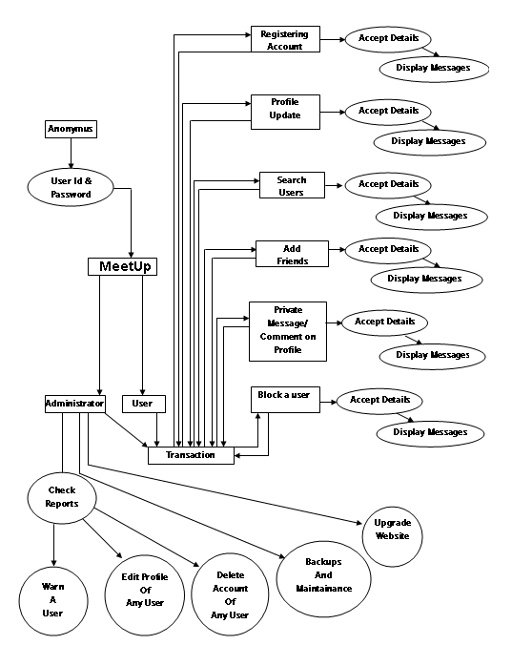

Context Level Diagram

User
User

Meet
Up
Details
Services
Reports
Warns

Upgrade
Maintainence

Admin
Reports



DFD IN DETAIL:

The DFD is short for Data Flow Diagram. It represents how the data flows in the processes.

- THE CONVENTIONS OF DFD:

PROCESS

DATA FLOW

EXTERNAL AGENT

DATA STORE

DFD Fragments

0th Level Diagram

0

MeetUp
(Registration)

Anonymus
Insert user detail
Store user
Detail
Get
User
Detail
Retrieve
User
Detail
USERS

1ST Level Diagram
1

Edit
Profile
USER
Insert profile detail
Store profile
Detail
Get Profile
Detail
Retrieve
Profile
Detail
USERS

2

Search
Users
USER
Insert UserName
Check UserName
Get UserName
Profile
Retrieve
UserName

USERS

3
ADD
User

USER
Get UserName
Profile
Request
To be
Friend

Wait for
Acceptance

Request
sent
FRIEND_
REQUESTS

4

Friend
Requests

USER
Get
Requests

FRIENDS

Retrieve
Requests
Made
Insert
Approvance
Details
Store Approvance
Details

5

Block
Users

USER
Insert User
Detail
Store User
Detail

Get
BlockedUser details

Retrieve
BlockedUser
Detail

BlockList

6

Albums
USER
Insert Detail

Store
Detail

Get Detail

Retrieve
Detail

album

7
Private
Message

USER
Insert Detail

Store
Detail
Get detail

Retrieve
Detail

PMessages

8
Report
Users

USER
Insert Detail

Store
Detail
Get detail

Retrieve
Detail

Reps

2ND Level Diagram
2.1

Upgrade

Admin
Insert web
Detail
Store Web
Detail

newtable

2.2
Check
Reports

Admin
Get
Report
Detail

Retrieve
Report
Detail

Reps

3RD Level Diagram
3.1.1

Warn
Users
Admin
Warnings

3.1.1

Edit
User
Admin

Users

3.1.3

Delete
User
Admin

Users

SITEMAP
Meet Up

HOME
PROFILE
MEMBER LIST
FRIEND REQUEST

COMMENT
ALBUM
INBOX
BLOCK USER
REPORT

EDIT USERS PROFILE
LOGOUT
ABOUT US

CONTACT US

FAQ

IMPLEMENTATION PHASE

- CODING AND SCREEN LAYOUTS

CONFIG.php
<?
ob_start(); // allows you to use cookies
$conn = mysql_connect("localhost","swapnil0545","123qwe");
mysql_select_db(newsat) or die(mysql_error());
//fill in the above lines where there are capital letters.
$logged = MYSQL_QUERY("SELECT * from users WHERE id='$_COOKIE[id]'");
$logged = mysql_fetch_array($logged);
//the above lines get the user's information from the database.
$logout_time = 300; //mili seconds to stay logged in
$current = time(); //current time
$offline = ($current - $logout_time); //do the math for the logout time
//if they are logged in
$update = mysql_query("UPDATE `users` SET `online` = '$current' WHERE `username` = '$logged[username]';");
//update their status
//end the check and such
?>

Validate.php

<?
function protect($content){
$content = mysql_real_escape_string($content);
$content = strip_tags($content);
$content = addslashes($content);
return $content;
}
function validateyahoo($value) {
if(ereg("^([0-9a-zA-Z]+[-._+&])*[0-9a-zA-Z]+@([-0-9a-zA-Z]+[.])+[a-zA-Z]{2,6}$", $value, $regs)) {
return true;
}
}
function validateEmail($value) {
if(ereg("^([0-9a-zA-Z]+[-._+&])*[0-9a-zA-Z]+@([-0-9a-zA-Z]+[.])+[a-zA-Z]{2,6}$", $value, $regs)) {
return true;
}
}
function GetAge($Birthdate){
list($BirthYear,$BirthMonth,$BirthDay) = explode("-", $Birthdate);
$YearDiff = date("Y") - $BirthYear;
$MonthDiff = date("m") - $BirthMonth;
$DayDiff = date("d") - $BirthDay;
if ($DayDiff < 0 || $MonthDiff < 0)
$YearDiff--;
return $YearDiff;
}
// Validation of an URL
function validateUrl($value) {
if(ereg("[a-zA-Z0-9\-\.]+\.[a-zA-Z]{2,3}(:[a-zA-Z0-9]*)?/?([a-zA-Z0-9\-\._\?\,\'/\\\+&amp;%\$#\=~])*[^\.\,\)\(\s]$", $value, $regs)) {
return true;
}
}
// Validation of characters
function validateAlpha($value) {
if(ereg("^[a-zA-Z]+$", $value, $regs)) {
echo "true";
$value=true;
return $value;
} else {
$value=false;
return $value;
}
}
// Validation of numbers
function validatephone($value) {
if(strlen($value)>9){
if(ereg("^[0-9]+$", $value, $regs)) {
return true;
} }
}

// Validation of numbers
function validatezipc($value) {
if(strlen($value)>3){
if(ereg("^[0-9]+$", $value, $regs)) {
return true;
}
}
}

?>

Template

header
Includes/header.php
<html xmlns="http://www.w3.org/1999/xhtml" lang="en">
<head>
<meta http-equiv="content-type" content="text/html; charset=utf-8" />
<link rel="stylesheet" type="text/css" media="screen,projection,print" href="./css/layout2_setup.css" />
<link rel="stylesheet" type="text/css" media="screen,projection,print" href="./css/layout2_text.css" />
<link rel="icon" type="image/x-icon" href="./img/favicon.ico" />
<title>Get Together</title>
</head>

<body>
<!-- Main Page Container -->
<div class="page-container">

<!-- A. HEADER -->
<div class="header">

<!-- A.1 HEADER MIDDLE -->
<div class="header-middle">

<!-- Sitelogo and sitename -->
<a class="sitelogo" href="#" title="Go to Start page"></a>
<div class="sitename">
<h1><a href="index.php" title="Go to Start page">Get Together<span style="font-weight:normal;font-size:50%;">&nbsp;version-1</span></a></h1>
<h2>connect with your friends</h2>
</div>

<!-- Navigation Level 1 del-->
<div class="nav1">
<ul>
<li><a href="index.php" title="Go to Start page">Home</a></li>
<li><a href="aboutus.php" title="Get to know who we are">About</a></li>
<li><a href="contactus.php" title="Get in touch with us">Contact</a></li>
<li><a href="faq.php" title="Get an overview of website">Faq</a></li>
</ul>
</div>
</div>

<!-- A.2 HEADER BREADCRUMBS -->
<!-- Breadcrumbs -->
<div class="header-breadcrumbs">
<?php if($logged[id]){?>
<!-- Search form -->
<div class="searchform">
<form action="search.php" method="post">
<fieldset>
<input type="text" name="search" class="field" title="Search Users" />
<input type="submit" name="button" class="button" value="GO!" title="Search Users"/>
</fieldset>
</form>
</div>
<? }?>
</div>
</div>
<!-- B. MAIN -->
<div class="main">

Menu
Includes/menu.php
<!-- B.1 MAIN NAVIGATION -->
<div class="main-navigation">
<!-- Navigation Level 3 -->
<div class="round-border-topright"></div>
<h2>Welcome</h2>
<?
// we now display the user controls.
$newms = mysql_query("select * from pmessages where unread = 'unread' and touser = '$logged[username]'");
$newms = mysql_num_rows($newms);
$newfr = mysql_query("select * from friend_requests where username = '$logged[username]'");
$newfr = mysql_num_rows($newfr);
$newsc = mysql_query("select * from members_comments where member_id = '$logged[id]'");
$newsc = mysql_num_rows($newsc);

echo ("<p>$logged[username]</p><p><img src='http://$logged[picture]' height='50px' width='50px'></p>"); ?>
<h1>Navigation</h1>
<dl class="nav3-grid">
<?echo"
<dt><a href='scrap.php?user=$logged[id]'>Scraps ($newsc)</a></dt>
<dt><a href='my_friends.php'>My friends</a></dt>
<dt><a href='gallery.php'>My Album</a></dt>
<dt><a href=\"messages.php\">Inbox ($newms New)</a></dt></dt>
<dt><a href=\"members.php\">Member List</a></dt>
<dt><a href='newfriends.php'>Friend Requests ($newfr New)</a></dt>
<dt><a href='blocklist.php'>Blocked friends</a></dt>
<dt><a href=\"editprofile.php\">Edit Profile</a></dt>
";
$get_warns = mysql_query("SELECT * FROM `warnings` WHERE `user` = '$logged[username]';");
$get_warns = mysql_num_rows($get_warns);
if($get_warns>0){
echo "<dt><a href='my_warns.php'>My warns($get_warns)</a></dt> ";
}
if($logged[level]==5){
echo "<hr><dt><a href='repcp.php'>Reports</a></dt> ";
echo "<dt><a href='admin.php'>Edit User Profile</a></dt> <hr>";
}
echo "<dt><a href=\"logout.php\">Logout</a></dt> ";
?>
</dl>
</div>

Footer
Footer.php
</div>
<!-- C. FOOTER AREA -->
<div class="footer">
<p class="credits">Designed by <a href="http://www.swapnil0545.byethost11.com" title="Designer Homepage">Swapnil,Anand And Tushar</a> | <a href="http://validator.w3.org/check?uri=referer" title="Validate XHTML code">W3C XHTML 1.0</a> | <a href="http://jigsaw.w3.org/css-validator/" title="Validate CSS code">W3C CSS 2.0</a></p>
</div>
</div>

</body>
</html>

Css
Layout setup1

Css/layout1_Setup.css
.main {clear:both; width:900px; padding-bottom:30px; background:transparent url(../img/bg_main_withoutnav.jpg) repeat-y;}
.main-content {display:inline; /*Fix IE floating margin bug*/; float:left; width:840px; margin:0 0 0 30px; overflow:visible !important /*Firefox*/; overflow:hidden /*IE6*/;}

Layout setup2
Css/layout2_setup.css
/* GLOBAL */
/* NON-HEADER */
*{padding:0; margin:0;}
body {font-size:62.5%; background-color:rgb(255,255,255); font-family:verdana,arial,sans-serif;} /*Font-size: 1.0em = 10px when browser default size is 16px*/
.page-container {width:900px; margin:0px auto; margin-top:10px; margin-bottom:10px; border:solid 1px rgb(150,150,150); font-size:1.0em;}
.main {clear:both; width:900px; padding-bottom:30px; background:transparent url(../img/bg_main_withnav.jpg) top left repeat-y;}
.main-navigation {display:inline /*Fix IE floating margin bug*/; float:left; width:200px; overflow:visible !important /*Firefox*/; overflow:hidden /*IE6*/;}
.main-content {display:inline; /*Fix IE floating margin bug*/; float:left; width:640px; margin:0 0 0 30px; overflow:visible !important /*Firefox*/; overflow:hidden /*IE6*/;}
.footer {clear:both; width:900px; height:3.7em; padding:1.1em 0 0; background:rgb(225,225,225) url(../img/bg_foot.jpg) no-repeat; font-size:1.0em; overflow:visible !important /*Firefox*/; overflow:hidden /*IE6*/;}
/* HEADER */
.header {width:900px; font-family:"trebuchet ms",arial,sans-serif;}
.header-middle {width:900px; height:150px; background:rgb(230,230,230) url(../img/bg_head_middle.jpg); overflow:visible !important /*Firefox*/; overflow:hidden /*IE6*/;}
.header-breadcrumbs {clear:both; width:900px; padding:1.0em 0 1.5em 0; background:rgb(100,100,100) url(../img/bg_head_breadcrumbs.jpg) repeat-y;}
/* 2. HEAD */
.sitelogo {width:60px; height:40px; position:absolute; z-index:1; margin:22px 0 0 20px; background:url(../img/bg_head_top_logo.jpg); }
.sitename {width:300px; height:45px; position:absolute; z-index:1; margin:20px 0 0 90px; overflow:visible !important /*Firefox*/; overflow:hidden /*IE6*/;}
.sitename h1 {font-size:240%;}
.sitename h2 {margin:-4px 0 0 0; color:rgb(234,239,247); font-size:120%;}
.sitename a {text-decoration:none; color:rgb(234,239,247);}
.sitename a:hover {text-decoration:none; color:rgb(50,50,50);}

.nav1 {width:350px; position:absolute; z-index:3; margin:45px 0 0 550px;}
.nav1 ul {float:right; padding:0 15px 0 0; font-weight:bold;}
.nav1 li {display:inline; list-style:none;}
.nav1 li a {display:block; float:left; padding:2px 5px 2px 5px; color:rgb(234,239,247); text-decoration:none; font-size:120%;}
.nav1 a:hover {text-decoration:none; color:rgb(50,50,50);}

.header-breadcrumbs .searchform {float:right; width:285px; padding:0 17px 0px 0px !important /*Non-IE6*/; padding:0 12px 0px 0px /*IE6*/;}
.header-breadcrumbs .searchform form fieldset {float:right; border:none;}
.header-breadcrumbs .searchform input.field {width:10.0em; padding:0.2em 0 0.2em 0; border:1px solid rgb(200,200,200); font-family:verdana,arial,sans-serif; font-size:120%; }
.header-breadcrumbs .searchform input.button {width:3.0em; padding:1px !important /*Non-IE6*/; padding:0 /*IE6*/; background:rgb(230,230,230); border:solid 1px rgb(150,150,150); text-align:center; font-family:verdana,arial,sans-serif; color:rgb(150,150,150); font-size:120%;}

/* MAIN SECTION */

/* MAIN NAVIGATION */
.main-navigation .round-border-topright {width:10px; height:10px; position:absolute; z-index:100; margin:0 0 0 190px; background:url(../img/bg_corner_topright.gif) no-repeat;}

/* MAIN CONTENT */
.column1-unit {width:640px; margin-bottom:10px !important /*Non-IE6*/; margin-bottom:5px /*IE6*/;}
.column2-unit-left {float:left; width:300px; margin-bottom:10px !important /*Non-IE6*/; margin-bottom:5px /*IE6*/;}
.column2-unit-right {float:right; width:300px; margin-bottom:10px !important /*Non-IE6*/; margin-bottom:5px /*IE6*/;}
input.button { margin-right:20px; padding:1px !important /*Non-IE6*/; padding:0 /*IE6*/; background:rgb(230,230,230); border:solid 1px rgb(150,150,150); text-align:center; font-family:verdana,arial,sans-serif; color:rgb(150,150,150); }
input.button:hover {cursor: pointer; border:solid 1px rgb(80,80,80); background:rgb(220,220,220); color:rgb(80,80,80);}
.column1-unit fieldset {rgb(200,200,200); background-color:rgb(240,240,240); padding:20px 0 0 0 !important /*Non-IE6*/; padding:0 /*IE6*/; margin:0 0 20px 0; border:solid 1px rgb(220,220,220);}
/* FOOTER SECTION */
.footer p {line-height:1.3em; text-align:center; color:rgb(125,125,125); font-weight:bold; font-size:110%;}
.footer p.credits {font-weight:normal;}
.footer a {text-decoration:underline; color:rgb(125,125,125);}
.footer a:hover {text-decoration:none; color:rgb(0,0,0);}
.footer a:visited {color:rgb(0,0,0);}

/* CLEAR FLOATS */
.page-container:after, .header:after, .header-breadcrumbs:after, .main:after, .main-navigation:after, .main-content:after {content:"."; display:block; height:0; clear:both; visibility:hidden;}
.column1-unit:after, .column2-unit-left:after, .column2-unit-right:after, .column3-unit-left:after, .column3-unit-middle:after, .column3-unit-right:after {content:"."; display:block; height:0; clear:both; visibility:hidden;}
.footer:after, p:after {content:"."; display:block; height:0; clear:both; visibility:hidden;}
.clear-contentunit {clear:both; width:640px; height:0.1em; border:none; background:rgb(210,210,210); color:rgb(210,210,210);}

Text layout
Css/Layout2_text.css
/* MAIN NAVIGATION */
.nav3-grid {width:199px; border-bottom:solid 1px rgb(200,200,200);}
.nav3-grid dt a, .nav3-grid dt a:visited {display:block; min-height:2.0em /*Non-IE6*/; height:auto !important; height:2.0em /*IE6*/; line-height:2.0em; padding:0px 10px 0px 20px; border-top: solid 1px rgb(200,200,200); text-decoration:none; color:rgb(70,122,167); font-weight:bold; font-size:120%;}
.nav3-grid dd a, .nav3-grid dd a:visited {display:block; min-height:1.7em /*Non-IE6*/; height:auto !important; height:1.7em /*IE6*/; line-height:1.7em; padding:0px 10px 0px 40px; border:none; font-weight:normal; text-decoration:none; color:rgb(70,122,167); font-size:120%;}
.nav3-grid dt a:hover, .nav3-grid dd a:hover {background-color:rgb(225,225,225); color:rgb(42,90,138); text-decoration:none;}

.main-navigation .searchform {width:160px; margin:0 20px 0 20px;}
.main-navigation .searchform fieldset {border:none;}
.main-navigation .searchform input.field {float:left; width:158px; padding:0.1em 0 0.2em 0 !important /*Non-IE6*/; padding:0.2em 0 0.3em 0 /*IE6*/; border:1px solid rgb(200,200,200); font-family:verdana,arial,sans-serif; font-size:120%;}
.main-navigation .searchform input.button {float:left; width:3.0em; margin-top: 0.5em; padding:1px; background:rgb(230,230,230); border:solid 1px rgb(150,150,150); text-align:center; font-family:verdana,arial,sans-serif; color:rgb(150,150,150); font-size:120%;}
.main-navigation .searchform input.button:hover {cursor:pointer; border:solid 1px rgb(80,80,80); background:rgb(220,220,220); color:rgb(80,80,80);}

.main-navigation h1.first {clear:both; margin:0px; padding:4px 20px 3px 20px; background-color:rgb(190,190,190); font-family:"trebuchet ms",arial,sans-serif; color:rgb(255,255,255); font-weight:bold; font-size:150%;}
.main-navigation h1 {clear:both; margin:30px 0 20px 0; padding:4px 20px 3px 20px; background:rgb(190,190,190); font-family:"trebuchet ms",arial,sans-serif; color:rgb(255,255,255); font-weight:bold; font-size:150%;}
.main-navigation h2 {clear:both; margin:20px 10px 10px 20px; font-family:"trebuchet ms",arial,sans-serif; color:rgb(100,100,100); font-weight:bold; font-size:150%;}
.main-navigation h3 {clear:both; margin:10px 10px 5px 20px; color:rgb(80,80,80); font-weight:bold; font-size:110%;} /* Note: h2 not existent, to make identical to formats for main-navigation for easier exchange */
.main-navigation p {clear:both; margin:0 10px 10px 20px; color:rgb(80,80,80); line-height:1.3em; font-size:110%;}
.main-navigation p.center {text-align:center;}
.main-navigation p.right {text-align:right;}

/* MAIN CONTENT */
.main-content h1.pagetitle {margin:0 0 0.4em 0; padding:0 0 2px 0; border-bottom:solid 7px rgb(225,225,225); font-family:"trebuchet ms",arial,sans-serif; color:rgb(100,100,100); font-weight:bold; font-size:220%;}
.main-content h1.block {clear:both; margin:1.0em 0 0em 0; padding:2px 0 2px 2px; background:rgb(190,190,190); font-family:"trebuchet ms",arial,sans-serif; color:rgb(255,255,255); font-weight:bold; font-size:220%;}
.main-content h1 {clear:both; margin:1.0em 0 0.5em 0; font-family:"trebuchet ms",arial,sans-serif; color:rgb(80,80,80); font-weight:normal; font-size:210%;}
.main-content h2 {clear:both; margin:1.0em 0 0.5em 0; font-family:"trebuchet ms",arial,sans-serif; color:rgb(80,80,80); font-weight:normal; font-size:170%;}
.main-content h3 {clear:both; margin:-1.0em 0 0.5em 0; font-family:"trebuchet ms",arial,sans-serif; color:rgb(125,125,125); font-weight:normal; font-size:130%;}

.main-content p {margin:0 0 1.0em 0; line-height:1.5em; font-size:120%;}
.main-content p.center {text-align:center;}

.main-content table {clear:both; width:600px; margin:2.0em 0 0.2em 20px; table-layout: fixed; border-collapse:collapse; empty-cells:show; background-color:rgb(233,232,244);}
.main-content table.album {clear:both; width:auto; margin:2.0em 0 0.2em 20px; table-layout: fixed; border-collapse:collapse; empty-cells:show; background-color:rgb(233,232,244);}
.main-content table th.top {height:3.5em; padding:0 7px 0 7px; empty-cells:show; background-color:rgb(175,175,175); text-align:left; color:rgb(255,255,255); font-weight:bold; font-size:110%;}
.main-content table th {height:3.0em; padding:2px 20px 2px 7px; border-left:solid 2px rgb(255,255,255); border-right:solid 2px rgb(255,255,255); border-top:solid 2px rgb(255,255,255); border-bottom:solid 2px rgb(255,255,255); background-color:rgb(225,225,225); text-align:left; color:rgb(80,80,80); font-weight:bold; font-size:110%;}
.main-content table td {height:3.0em; padding:2px 7px 2px 7px; border-left:solid 2px rgb(255,255,255); border-right:solid 2px rgb(255,255,255); border-top:solid 2px rgb(255,255,255); border-bottom:solid 2px rgb(255,255,255); background-color:rgb(225,225,225); text-align:left; font-weight:normal; color:rgb(80,80,80); font-size:110%;}
p.caption {clear:both; margin:0.5em 0 2.0em 20px; text-align:left; color:rgb(80,80,80); font-size:110%;}

.contactform {width:418px; margin:2.0em 0 0 0; padding:10px 10px 0 10px; border:solid 1px rgb(200,200,200); background-color:rgb(240,240,240);}
.contactform fieldset {padding:20px 0 0 0 !important /*Non-IE6*/; padding:0 /*IE6*/; margin:0 0 20px 0; border:solid 1px rgb(220,220,220);}
.contactform fieldset legend {margin:0 0 0 5px !important /*Non-IE*/; margin:0 0 20px 5px /*IE6*/; padding:0 2px 0 2px; color:rgb(80,80,80); font-weight:bold; font-size:130%;}
.contactform label.left {float:left; width:100px; margin:0 0 0 10px; padding:2px; font-size:110%;}
.contactform select.combo {width:175px; padding:2px; border:solid 1px rgb(200,200,200); font-family:verdana,arial,sans-serif; font-size:110%;}
.contactform input.field {width:275px; padding:2px; border:solid 1px rgb(200,200,200); font-family:verdana,arial,sans-serif; font-size:110%;}
.contactform textarea {width:275px; padding:2px; border:solid 1px rgb(200,200,200); font-family:verdana,arial,sans-serif; font-size:110%;}
.contactform input.button {float:right; width:9.0em; margin-right:20px; padding:1px !important /*Non-IE6*/; padding:0 /*IE6*/; background:rgb(230,230,230); border:solid 1px rgb(150,150,150); text-align:center; font-family:verdana,arial,sans-serif; color:rgb(150,150,150); font-size:110%;}
.contactform input.button:hover {cursor: pointer; border:solid 1px rgb(80,80,80); background:rgb(220,220,220); color:rgb(80,80,80);}

.loginform {width:160px; margin:-10px 20px 0 20px;}
.loginform p {clear:both; margin:0; padding:0;}
.loginform fieldset {width:160px; border:none;}
.loginform input.field {width:158px; margin:0 0 5px 0; padding:0.1em 0 0.2em 0 !important /*Non-IE6*/; padding:0.2em 0 0.3em 0 /*IE6*/; border:solid 1px rgb(200,200,200); font-family:verdana,arial,sans-serif; font-size:110%;}
.loginform input.button {float:left; width:5.0em; margin:10px 0 5px 0; padding:1px; background:rgb(230,230,230); border:solid 1px rgb(150,150,150); text-align:center; font-family:verdana,arial,sans-serif; color:rgb(150,150,150); font-size:110%;}
.loginform input.button:hover {cursor:pointer; border:solid 1px rgb(80,80,80); background:rgb(220,220,220); color:rgb(80,80,80);}

/* COMMON CLASSES */
.main img {clear:both; float:left; margin:3px 10px 7px 0; padding:1px; border:1px solid rgb(150,150,150);}
.main img.center {clear:both; float:none; margin:0; padding:1px; border:1px solid rgb(150,150,150);}
.main img.right {clear:both; float:right; margin:3px 0 7px 10px; padding:1px; border:1px solid rgb(150,150,150);}

.main a {color:rgb(70,122,167); font-weight:bold; text-decoration:none;}
.main-content h1 a {color:rgb(70,122,167); font-weight:normal; text-decoration:none;}
.main a:hover {color:rgb(42,90,138); text-decoration:underline;}
.main a:visited {color:rgb(42,90,138);}

.main a img {border:solid 1px rgb(150,150,150);}
.main a:hover img {border:solid 1px rgb(220,220,220);}

1. Registration Page

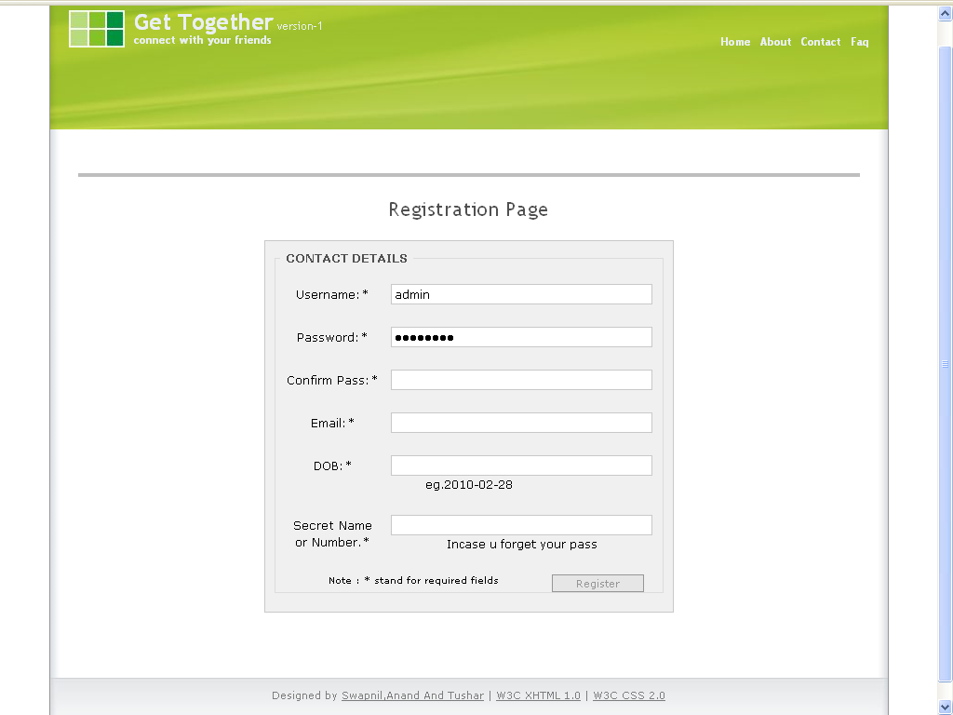

Name: Registration Page

Description: This page allows the new users to register themselves in this site.

Source Code of Registration Page
Register.php

<?
include("config.php");
include("validate.php");
$page_title='Registration Page';
include("includes/header.php");
?>
<div class="main">
<link rel="stylesheet" type="text/css" media="screen,projection,print" href="./css/layout1_setup.css" />
<!-- B.1 MAIN CONTENT -->
<div class="main-content" align="center">
<!-- Content unit - One column -->
<h1 class="block"><?php echo ("<h1>$page_title</h1>"); ?>
<div class="column1-unit">
<div class="contactform">
<?php
//gets the config page
if ($_POST[register]) {
// the above line checks to see if the html form has been submitted
$username = $_POST[username];
$password = $_POST[pass];
$cpassword = $_POST[cpass];
$email = $_POST[emai1];
$dob = $_POST[dob];
$secret = $_POST[secret];
//the above lines set variables with the user submitted information
if($username==NULL|$password==NULL|$cpassword==NULL|$email==NULL|$secret==NULL) {
//checks to make sure no fields were left blank
echo "A field was left blank.";
}elseif(strlen($password) <= 5 || strlen($password) >= 20 ){
echo "password must be over 6 and under 20";
}elseif (strlen($password) > 5 || strlen($password) < 20){
if(!eregi("^[_a-z0-9-]+(\.[_a-z0-9-]+)*@[a-z0-9-]+(\.[a-z0-9-]+)*(\.[a-z]{2,4})$", $email)) {
echo "Pls enter valid email";}
elseif (ereg('[^A-Za-z0-9]', $rusername)) {
echo "Your username can only contain letters and numbers.";
}elseif (!ereg('[^A-Za-z0-9]', $username)) {
/// This line basically checks if your using certain characters in your username and doesnt allow them.
if (strlen($username) <= 3 || strlen($username) >= 20 ){
echo "Username must be over 3 and under 20";
}elseif (strlen($username) > 3 || strlen($username) < 20){
/// This checks if your username is below 20 characters or above 3 characters and allows only that unless you change it.
//none were left blank! We continue...
if($password != $cpassword) {
// the passwords are not the same!
echo "Passwords do not match";
}else{
// the passwords are the same! we continue...
$password = md5($password);
// encrypts the password
$checkname = mysql_query("SELECT username FROM users WHERE username='$username'");
$checkname= mysql_num_rows($checkname);
$checkemail = mysql_query("SELECT email FROM users WHERE email='$email'");
$checkemail = mysql_num_rows($checkemail);
if ($checkemail>0|$checkname>0) {
// oops...someone has already registered with that username or email!
echo "<meta http-equiv=\"Refresh\" content=\"0; URL=register.php\"/>The username or email is already in use";
}else{
// noone is using that email or username! We continue...
$username = protect($username);
$password = protect($password);
$email = protect($email);
$dob = protect($dob);
$secret= protect($secret);
// the above lines make it so that there is no html in the user submitted information.
//Everything seems good, lets insert.
$Agediff=GetAge($dob);
If($Agediff>=9 && $Agediff<101){
$query = mysql_query("INSERT INTO users (username, password, email,dob,secret) VALUES('$username','$password','$email','$dob','$secret')");
echo ("<meta http-equiv=\"Refresh\" content=\"0; URL=index.php\"/>You have successfully registered! ");
}else{
echo "<h1>Enter a Valid Date Of Birth.</h1>";
}
}}}}}}
// inserts the information into the database.
else{// the form has not been submitted...so now we display it.
echo ("
<form method=\"POST\">
<fieldset>
<legend>&nbsp;CONTACT DETAILS&nbsp;</legend>
<p><label class='left'>Username:*</label<input type=\"text\" size=\"15\" maxlength=\"25\" name=\"username\" class='field'></p><br />
<p><label class='left'>Password:*</label<input type=\"password\" size=\"15\" maxlength=\"25\" name=\"pass\" class='field'></p><br />
<p><label class='left'>Confirm Pass:*</label><input type=\"password\" size=\"15\" maxlength=\"25\" name=\"cpass\" class='field'></p><br />
<p><label class='left'>Email:*</label<input type=\"text\" size=\"40\" maxlength=\"40\" name=\"emai1\" class='field'></p><br />
<p><label class='left'>DOB:*</label<input type=\"text\" size=\"15\" maxlength=\"25\" name=\"dob\" class='field'>eg.2010-02-28</p><br />
<p><label class='left'>Secret Name or Number.*</label<input type=\"password\" size=\"20\" maxlength=\"25\" name=\"secret\" class='field'>Incase u forget your pass</p><br />
<input name=\"register\" type=\"submit\" value=\"Register\" class='button'>
Note : * stand for required fields
</fieldset></form>
");
}
?>
</div></div></div></div>
<?include("includes/footer.php");?>

- Index Form

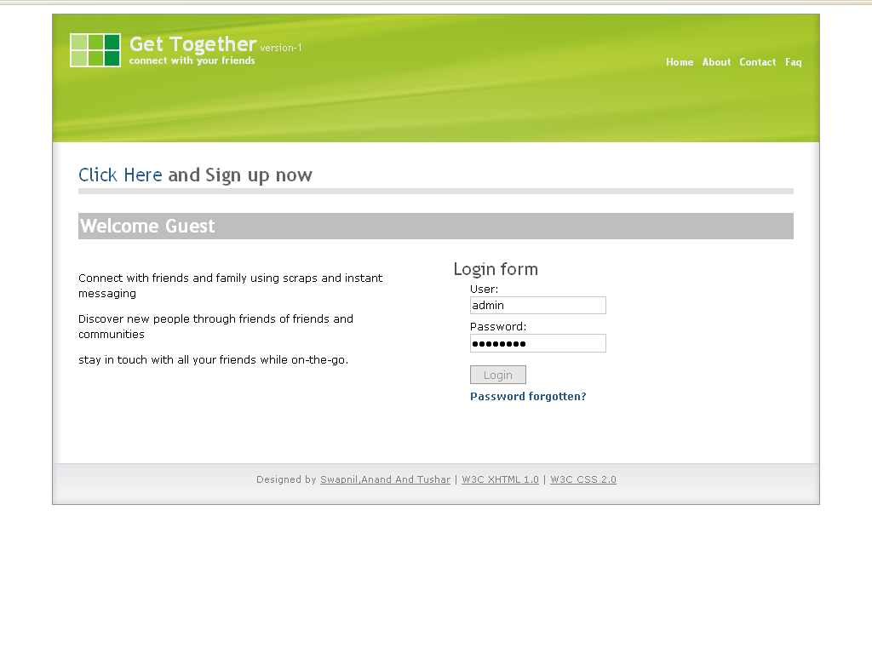
Name: Index.php

Description: This form welcomes the User

Source Code of Index.php

<?
include("config.php");
$page_title='Login';
include("includes/header.php");
?>
<link rel="stylesheet" type="text/css" media="screen,projection,print" href="./css/layout1_setup.css" />
<!-- B. MAIN -->
<div class="main">
<?php
if ($logged[username]){
echo("<meta http-equiv=\"Refresh\" content=\"0; URL=home.php\"/>Thank You! You will be redirected");
}
else{
?>
<!-- B.1 MAIN CONTENT -->
<div class="main-content">
<!-- Pagetitle -->
<h1 class="pagetitle"><a href="register.php">Click Here</a> and Sign up now</h1>
<!-- Content unit - Two columns -->
<h1 class="block">Welcome Guest</h1>
<div class="column2-unit-right">
<h1>Login form</h1>
<div class="loginform">
<form method="post" action="login.php">
<fieldset>
<p>User:<br />
<input type="text" name="username" id="username" tabindex="1" class="field"" /></p>
<p>Password:<br />
<input type="password" name="password" id="password" tabindex="2" class="field" /></p>
<p><input type="submit" name="login" class="button" value="Login" /></p>
<p><a href="forgot.php" id="forgotpsswd">Password forgotten?</a></p>
</fieldset>
</form>
</div>
</div>
<div class="column2-unit-left"> <br/> <br/> <br/>
<p>Connect with friends and family using scraps and instant messaging</p>
<p>Discover new people through friends of friends and communities </p>
<p> stay in touch with all your friends while on-the-go. </p>
</div>
<!-- Content unit - One column -->
</div>
</div>
<? }?>
<?include("includes/footer.php");?>

Login.php
<?php
include("config.php");
if (!$logged[username])
{
if (!$_POST[login])
{
echo("<meta http-equiv=\"Refresh\" content=\"0; URL=index.php\"/>Thank You! You will be redirected");
}
if ($_POST[login]) {
// the form has been submitted. We continue...
$username=$_POST['username'];
$password = md5($_POST[password]);
//gets the username data from the members database
// the above lines set variables with the submitted information.
$info = mysql_query("SELECT * FROM users WHERE username = '$username'") or die(mysql_error());
$data = mysql_fetch_array($info);
if($data[password] != $password) {
// the password was not the user's password!
echo "Incorrect username or password!";
}else{
// the password was right!
$query = mysql_query("SELECT * FROM users WHERE username = '$username'") or die(mysql_error());
$user = mysql_fetch_array($query);
// gets the user's information
setcookie("id", $user[id],time()+(60*60*24*5), "/", "");
setcookie("pass", $user[password],time()+(60*60*24*5), "/", "");
// the above lines set 2 cookies. 1 with the user's id and another with his/her password.
echo ("<meta http-equiv=\"Refresh\" content=\"0; URL=home.php\"/>Thank You! You will be redirected");
// modify the above line...add in your site url instead of yoursite.com
}
}
}else{
$page_title='Home';
// we now display the user controls.
$new = mysql_query("select * from pmessages where unread = 'unread' and touser = '$logged[username]'");
$new = mysql_num_rows($new);
$newfr = mysql_query("select * from friend_requests where username = '$logged[username]'");
$newfr = mysql_num_rows($newfr);
echo ("<meta http-equiv=\"Refresh\" content=\"0; URL=home.php\"/>Thank You! You will be redirected
");
}
?>

Logout.php

<?
include"config.php";
$sql = " UPDATE users set online = 0 WHERE id = $logged[id]";
MYSQL_QUERY($sql);
setcookie("id", 2132421,time()+(60*60*24*5), "/", "");
setcookie("pass", loggedout,time()+(60*60*24*5), "/", "");
echo ("<meta http-equiv=\"Refresh\" content=\"0; URL=index.php\"/>Thank You! You will be redirected");
?>

3. Forget Password

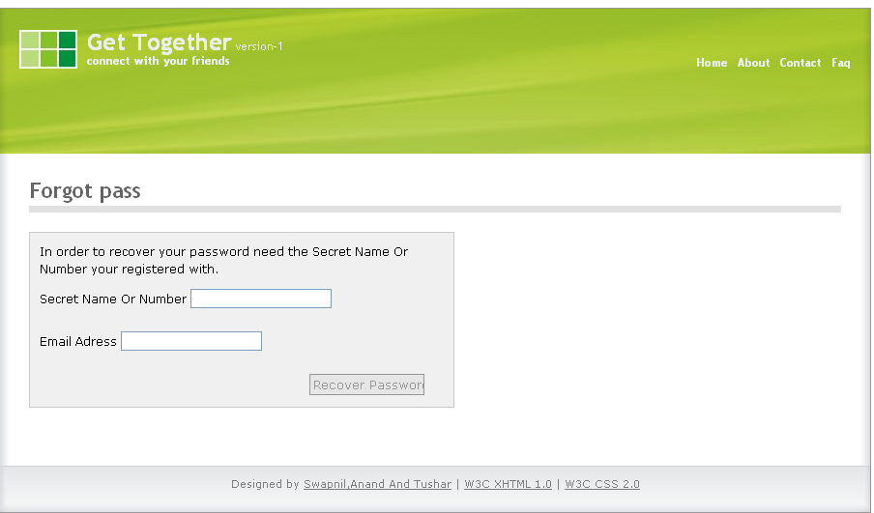

Name: Forget Password

Description: This page allows the user to input their secret name or number along with E-mail addr to retrive the new password.

Source Code of Forgot Password
Forgotpass

<?php
include("config.php");
$page_title='Forgot pass';
include("includes/header.php");
?>
<div class="main">
<link rel="stylesheet" type="text/css" media="screen,projection,print" href="./css/layout1_setup.css" />
<!-- B.1 MAIN CONTENT -->
<div class="main-content">
<!-- Pagetitle -->
<h1 class="pagetitle"> <?php echo "$page_title"; ?> </h1>
<?
if (!$_POST['lost_pass']) {//the form hasn't been submitted, we make it
echo ("<div class='contactform'>
<p>In order to recover your password need the Secret Name Or Number your registered with.\n<br \>
<form method=post><p>Secret Name Or Number <input type=text name=secret></p><br />
<p>Email Adress <input type=text name=email></p><br />
<p><input type=\"submit\" name=\"lost_pass\" value='Recover Password' class='button'></p>
</form>");
}else{
$secret = $_POST['secret']; //this is making the $email the input into the email part in the form
$sql = "SELECT * FROM users WHERE secret='$secret'"; //this is checking the emails in the database looking for the one posted in the form
$checksecret = mysql_query($sql)
or die(mysql_error());
//the above lines look for the email address in the member table
if (mysql_num_rows($checksecret) == "0") {
exit("We can't find that Secret Nick in our member database,
please make sure you entered the correct secret");
}//if the email doesn't exist, tell the user it doesn't
$checksecret = mysql_fetch_array($checksecret);
$user = $checksecret['username'];
// Random Password Generator
$alphanum = "ABCDEFGHIJKLMNOPQRSTUVWXYZabcdefghijklmnopqrstuvwxyz0123456789";
//shuffles the letters around to create a 16 long code
$code = substr(str_shuffle($alphanum), 0, 7);
$newpassword = md5($code);
$update = "UPDATE `users` SET `password` = '" . $newpassword . "' WHERE `username` = '" . $user . "'";
mysql_query($update) or die(mysql_error());
//change the member's password to the new generated one
$subject = "<h1>Password Recovery</h1>"; //here is the subject of the email
$message = ("<p>Dear $user, The email was generated because it has come to our attention that you have forgot your password.<br/>
Please find below your new password once you have logged into your account please go into your control panel and change your password.<br/>
New Password: " . $code . "<br/>
Thank you for using the password recovery service, have a nice day</p>"); //this is what is displayed in the email
$sender = "<h3>swapnil@getogether.com</h3>"; //change this to your site
//mail($email, $subject, $message, $sender)
echo " $subject $message $sender";
echo ("<hr><p>Password Reset Successful - Please login to your email account and find an email from our site with your new password.</p>");
}
?>
</div> </div></div>
<?include("includes/footer.php");?>

4. Home Page

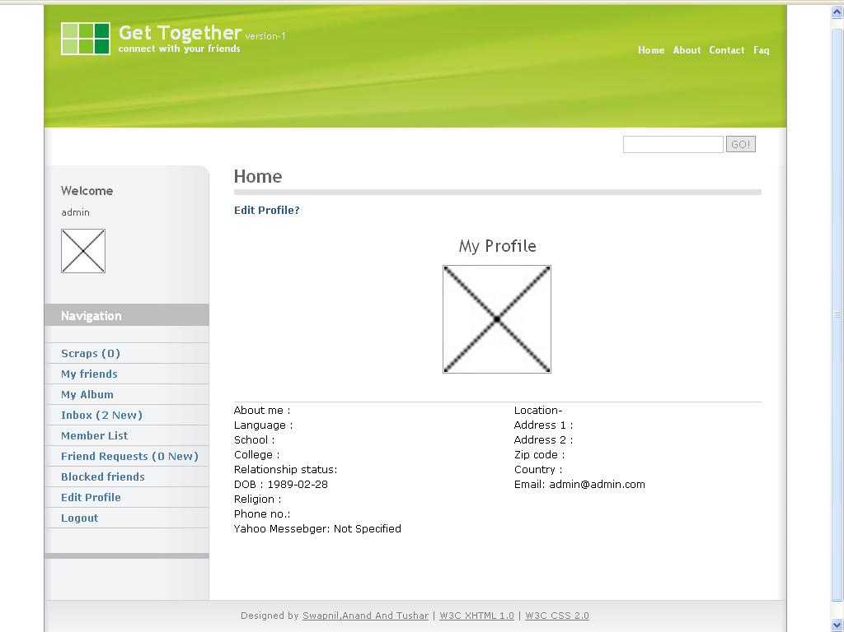

Name: Home Page

Description: This page welcomes the users in to the website and shows his/her profile.

Source Code of Home Page
<?
include("config.php");
$page_title='Home';
include("includes/header.php");
include("includes/menu.php");
?>
<!-- B.1 MAIN CONTENT -->
<div class="main-content">
<!-- Pagetitle -->
<h1 class="pagetitle"> <?php echo "$page_title"; ?> </h1>
<?php
if ($logged[username]){// User is logged in
$profile = mysql_query("SELECT * from users where username = '$logged[username]'");
$profile = mysql_fetch_array($profile);
// Above lines get info of logged user
echo("
<p><a href='editprofile.php'>Edit Profile?</a></p>
<h1 align='center'> My Profile</h1>
<p class='center'>
<IMG class='center' SRC='http://$profile[picture]' height='128' width='128'>
<br /><br /></p>
<hr class='clear-contentunit' />
<div class='column2-unit-left'><p>
About me : $profile[abtme]<br />
Language : $profile[lang]<br />
School : $profile[scl]<br />
College : $profile[col]<br />
Relationship status: $profile[rstats]<br />
DOB : $profile[dob]<br />
Religion : $profile[rlgn]<br />
Phone no.: $profile[pno]<br />
Yahoo Messebger: $profile[yahoo]<br />
</p></div>
<div class='column2-unit-right'><p>
Location-<br />
Address 1 : $profile[add1]<br />
Address 2 : $profile[add2]<br />
Zip code : $profile[zipc]<br />
Country : $profile[ctry]<br />
Email: $profile[email]<br />
</p></div>
");
}else{// They aren't logged in!
echo ("<a href='login.php'>You must login</a>");
}
?> </div> <?include("includes/footer.php");?>
  - Comments Page

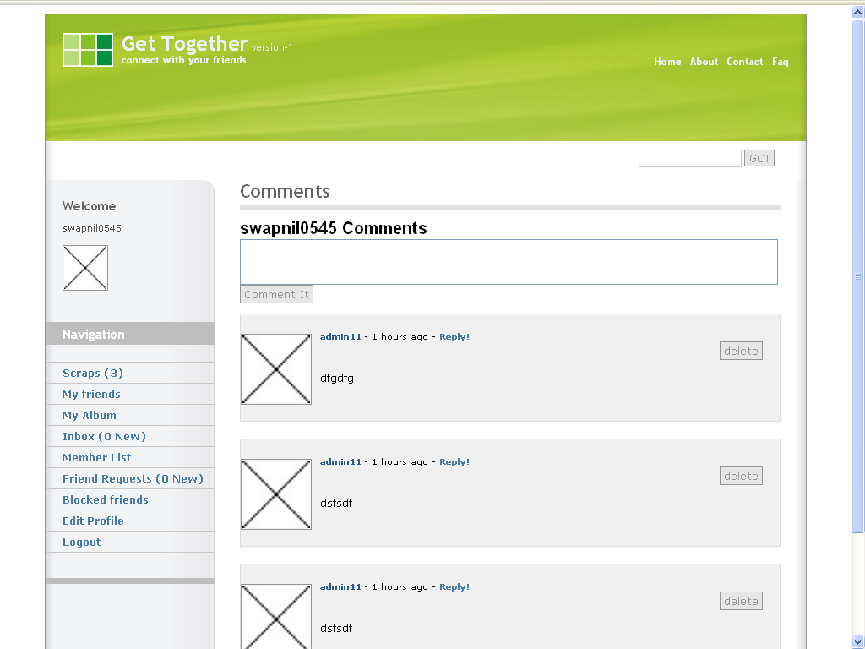
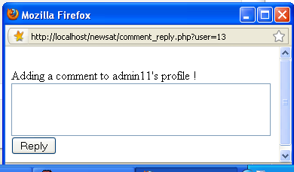

Name: Comments Page

Description: This page shows the user the comments he/she has and allows them to reply them.

Source Code of Comments Page

<?
include("config.php");
$page_title='Comments';
include("includes/header.php");
include("includes/menu.php");
?>
<!-- B.1 MAIN CONTENT -->
<div class="main-content">
<!-- Pagetitle -->
<h1 class="pagetitle"> <?php echo "$page_title"; ?> </h1>
<div class="column1-unit">
<?php
$user = mysql_real_escape_string($_GET['user']);
if(!$logged['id']){
echo("You need to be logged in to post a comment! <a href='index.php'>Login Here!</a>");
}else{
if($_POST['deleteid']){//delete post
$del = $_POST['delid'];
mysql_query("DELETE FROM `members_comments` Where id=$del");
echo ("<meta http-equiv=\"Refresh\" content=\"0; URL=scrap.php?user=$logged[id]\"/>Thank You! You will be redirected");
}//delete post complete
//check if the message is posted by a user and post a message
if($_POST['message'] AND $_POST['user']){
$message = mysql_real_escape_string($_POST['message']);
$to = $_POST['user'];
mysql_query("INSERT INTO `members_comments` VALUES ('','$to','$logged[id]','$message',unix_timestamp())");
echo ("<meta http-equiv='Refresh' content='1;'/>Comment posted");
}else{
$get_member = mysql_query("SELECT * FROM `users` WHERE `id` = '$_GET[user]'");
$member = mysql_fetch_array($get_member);
if(!mysql_num_rows($get_member)) {
echo "This member does not exist! <a href='members.php?user=$_POST[user]'>Back</a>";
}else{
echo ("<form action='scrap.php?user=$member[id]' method='POST'>
<input type='hidden' name='user' value='$_GET[user]'>
<span style='margin-bottom: 10px; font: bold 20px Arial;'>$member[username] Comments</span><br/>
<textarea name='message' style='width: 99%; height: 50px;'></textarea>
<input type='submit' value='Comment It' class='button'/>
</form><br/>");
}
} //checking of message complete
// Getting the comments
$get_comments = mysql_query("SELECT * FROM `members_comments` WHERE `member_id` = '$member[id]' ORDER BY `id` DESC LIMIT 20");
$row = mysql_num_rows($get_comments);
if($row == "0"){// Checking if there is comments if not saying there are no comments. =]
echo "<center>$member[username] has no comments at the moment! </center>";
}else{// Displaying all the comments now.
while($comments = mysql_fetch_array($get_comments)){
$get_member = mysql_query("SELECT * FROM `users` WHERE `id` = '$comments[from_id]'");
$member = mysql_fetch_array($get_member);
echo("<fieldset>
<a href=\"?user=$user[username]\">
<img src='http://$member[picture]' height='80' width='80' /></a>
<a href=\"?user=$member[id]\">$member[username] </a> " );
// Showing how long the comment was posted!
$time = time() - $comments['time'];
$in = "seconds";
if($time >= 60){
$time = (int) ($time/60);
$in = "minute(s)";
}
if($time >= 60){
$time = (int) ($time/60);
$in = "hours";
if($time >= 24){
$time = (int) ($time/24);
$in = "days";
}
}
if($logged['id'] == $user){
?>
<script type="text/javascript">
// Popup window code
function newPopup(url) {
popupWindow = window.open(
url,'popUpWindow','height=200,width=400,left=450,top=450,resizable=yes,scrollbars=yes,toolbar=no,menubar=no,location=no,directories=no,status=yes')
}
</script>

<?// if not then dont dispay a reply link.
echo("- $time $in ago - <a href=\"JavaScript:newPopup('comment_reply.php?user=$comments[from_id]')\">Reply!</a> <div align='right'>
<form action='scrap.php?user=$member[id]' method='POST'>
<input type='hidden' name='user' value='$_GET[user]'>
<input type='hidden' name='delid' value='$comments[id]' />
<input type='submit' name='deleteid' value='delete' class='button'/>
</form> </div><br/>");
} else{ echo (" - $time $in ago "); }
echo "<p> $comments[content] </fieldset>";
//custom
}
}}
?>
</div></div>
<?include("includes/footer.php");?>

6. My Friends

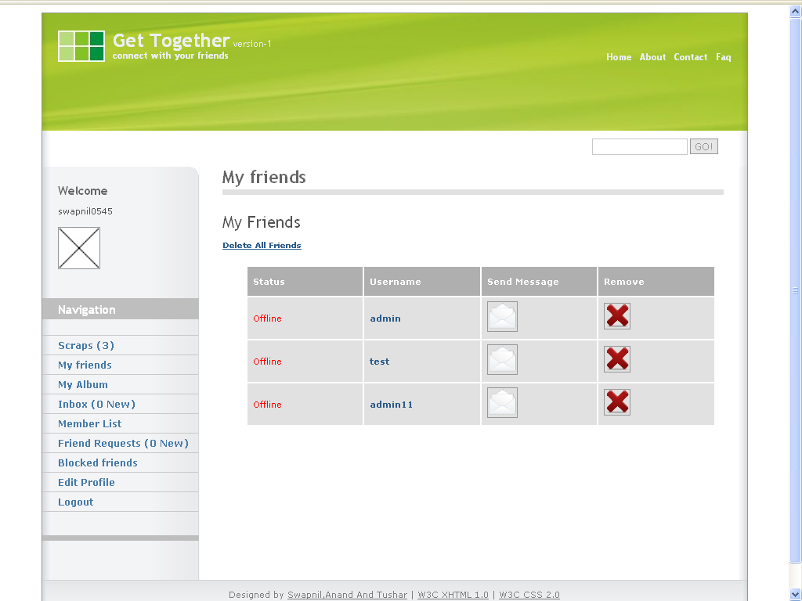

Name: My Friends

Description: This page shows the user their current friends list and allows them to go to their profile, message them or remove them from their friends list.

Source Code of My Friends
<?
include("config.php");
$page_title='My friends';
include("includes/header.php");
include("includes/menu.php");
?>
<!-- B.1 MAIN CONTENT -->
<div class="main-content">
<!-- Pagetitle -->
<h1 class="pagetitle"> <?php echo "$page_title"; ?> </h1>
<?
//check user is logged in or not
if (!$logged["username"]) {
echo ("<meta http-equiv=\"Refresh\" content=\"1; URL=login.php\"/>Thank You! You will be redirected");
exit;
}
switch($_GET[page]){ //make some links ?page=case
case 'deleteall': // delete page
$delete = mysql_query( "DELETE FROM `friends` WHERE `username` = '$logged[username]' "); // deletes friend request
echo ( "You have deleted all your friends." ); // echos completion
break; //ends delete page
case 'delete': // delete page
if ($_GET[user]) { //get username
$delete = mysql_query( "DELETE FROM `friends` WHERE `friendname` = '$_GET[user]' "); // deletes friend request
echo ( "$_GET[user] has been deleted from your friendlist." ); // echos completion
}
break; //ends delete page
default: //set up the default page upon going to inbox.php
$afed = mysql_query("SELECT * FROM `friends` WHERE `username` = '$logged[username]' OR 'friendname' = '$logged[username]' ORDER BY `id` ASC") or die(mysql_error());
//loops there name out
echo "<h1>My Friends</h1>
<a href='?page=deleteall'><u>Delete All Friends</u></a><center>
<table align=center>
<tr align='center' id='top'>
<th class='top' scope='col'>Status</th>
<th class='top' scope='col'>Username</th>
<th class='top' scope='col'>Send Message</th>
<th class='top' scope='col'>Remove</th></tr>";
while ($fr = mysql_fetch_array($afed)) {
$fid = mysql_query("SELECT * FROM `users` WHERE `username` = '$fr[friendname]' ") or die(mysql_error());
$fri = mysql_fetch_array($fid);
echo "<tr align='center'>
<td> "; if($fri[online]>= $offline) echo"<font color='green'>Online</font>";
else echo "<font color='red'>Offline</font>";
echo "</td>
<td><a href='members.php?user=$fri[id]'>$fr[friendname]</a></td>
<td><a href='messages.php?page=write&;page=msgto&amp;user=$fri[username]'>
<img src='images/Mail.png' border='0' title='Send Message'></a></td>
<td><a href='?page=delete&amp;user=$fr[friendname]'>
<img src='images/delete64.png' border='0' title='Remove Friend?'></a></td>
</tr>";
}
echo "</table></center>";
break;
}
?>
</div>
<?include("includes/footer.php");?>

7.Album Page
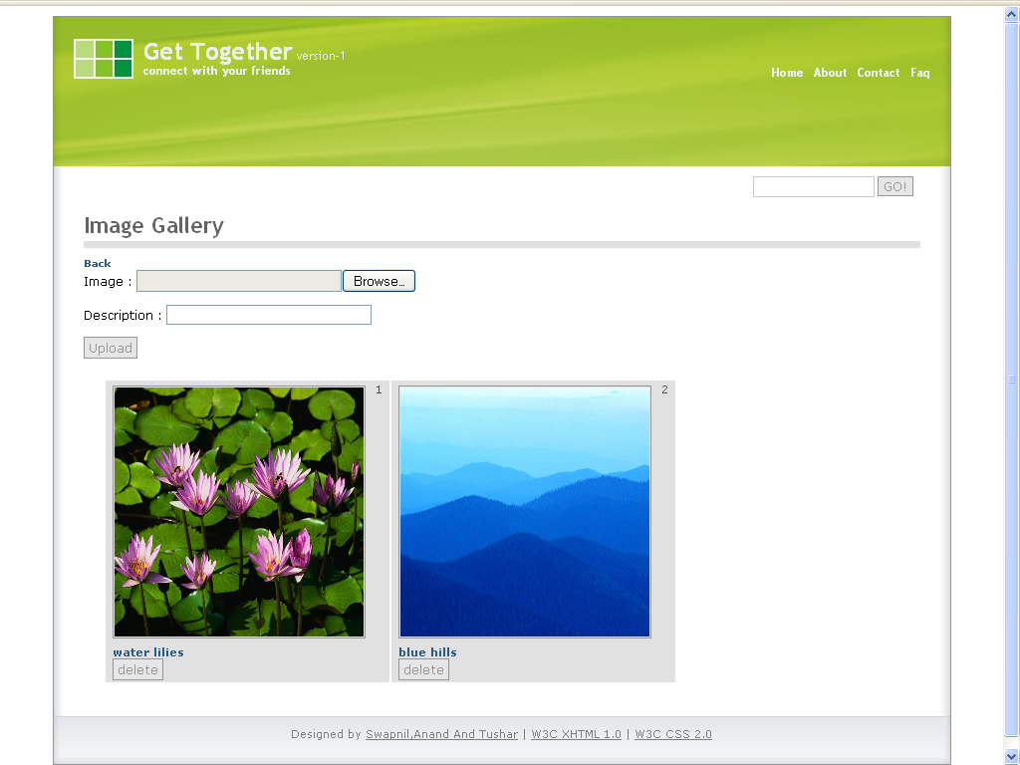

Name: Album Page

Description: This pageallows the user to upload new images and current images.

Source Code of Album:
<?
include("config.php");
include("includes/header.php");
$counter=1;
?>
<link rel="stylesheet" type="text/css" media="screen,projection,print" href="./css/layout1_setup.css" />
<!-- B.1 MAIN CONTENT -->
<div class="main-content"><!-- Pagetitle -->
<h1 class="pagetitle">Image Gallery</h1>
<?
if($logged['username']){//delete post
if($_POST['deleteid']){
$del = $_POST['delid'];
mysql_query("DELETE FROM `album` Where id=$del");
echo ("<meta http-equiv='Refresh' content='1; URL=gallery.php?user=$logged[id]'/>T
hank You! You will be redirected");
}
if($_GET[user]){
$userid = $_GET[user];
}else{
$userid = $logged[id];
}
$display = mysql_query( "SELECT * FROM `album` WHERE userid=$userid ORDER BY `id` ASC" ); // get values
echo (" <a href='index.php'>Back</a>");
if($logged['id']==$userid){
include("submitimage.php");
}
echo "<table width='900' class='album'> <tr>";
while ($imgs = mysql_fetch_array($display))
{
echo "<td>$counter
<a href='$imgs[image]' target='_BLANK'>
<img src='$imgs[image]' height='250' width='250' >
</a><a href='members.php?user=$imgs[userid]'><br/>$imgs[desc]</a>
<form action='gallery.php?user=$member[id]' method='POST'>
<input type='hidden' name='delid' value='$imgs[id]' />
<input type='submit' name='deleteid' value='delete' class='button'/>
</form>
</td>
"; //echos the image
if($counter%3==0){
echo "<tr>";
}
$counter++;
}
echo ("</tr></table> ");
}else echo ("login");
?>
</div>
<?include("includes/footer.php");?>

Submitimage.php
<?
include("validate.php");
if ($logged["username"]) { //checks user is logged in
if ($_POST["submit"]) { //check if forum was submitted
//This function separates the extension from the rest of the file name and returns it
function findexts ($filename)
{
$filename = strtolower($filename) ;
$exts = split("[/\\.]", $filename) ;
$n = count($exts)-1;
$exts = $exts[$n];
return $exts;
}
$ext = findexts ($_FILES['image']['name']);//This applies the function to our file
$ran = rand () ;
$ran2 = $ran.".";
$target = "images/"; //destination
$target = $target . $ran2.$ext;
if(move_uploaded_file($_FILES['image']['tmp_name'], $target))
{
$image = $target;
$userid= protect(($logged["id"])); //username
$username = protect(($logged["username"])); //username
$desc = protect(($_POST["desc"])); // orignal url
$do = mysql_query( "INSERT INTO `album` ( `userid` ,`username` , `desc` , `image` ) VALUES ( '$userid' ,'$username' , '$desc' , '$image' ) ");
echo ("<meta http-equiv=\"Refresh\" content=\"1; URL=gallery.php?user=$logged[id]\"/>Thank You! Image submitted"); }
else{ echo ("There was a problem uploading your file"); }//else error
}else{
echo "<form enctype='multipart/form-data' method='POST'>
<p>Image : <input type='file' size='30' name='image' ></p>
<p>Description : <input type='text' size='30' name='desc'></p>
<input type='submit' name='submit' value='Upload' class='button'>
</form>"; //echos form
}
}else{ echo ("you need to be logged in"); }
?>

8. Private Messages

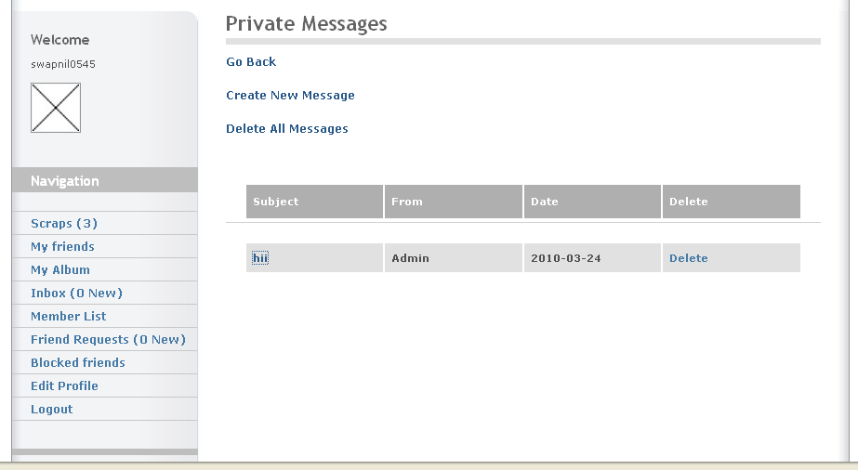
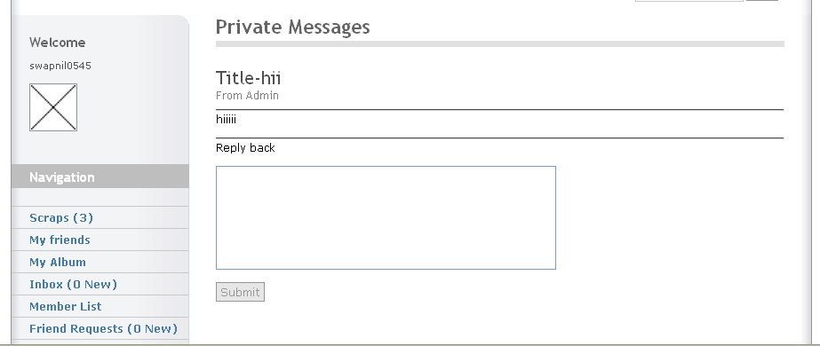

Name: Private Messages

Description: This page allows the user to send private message to their friends and also to view received one.

Source Code of Private Messages
<?
include("config.php");
include("validate.php");
$page_title='Private Messages';
include("includes/header.php");
include("includes/menu.php");
?>
<div class="main-content">
<!-- Pagetitle -->
<h1 class="pagetitle"> <?php echo "$page_title"; ?> </h1>
<div class="column1-unit">
<!-- Content unit - One column -->
<div class='column1-unit'>
<?php
if ($logged[username]){//checks to see if they are logged in
$getfoe = mysql_query("SELECT * FROM `blocklist` WHERE `foe` = '$logged[username]'");
$en = mysql_fetch_array($getfoe);
switch($_GET[page])
{
//this allows us to use one page for the entire thing
default:
echo"
<meta http-equiv='refresh' content='0;URL=messages.php?page=inbox'>
";
break;
case 'write':
if (!$_POST[send]){
if ($_POST[send] && $_POST[to] == $en[username]){
echo "<b>Error:</b> This user has blocked you from sending any PMs to you.";
}else{//the form hasnt been submitted yet....
echo("
<a href='messages.php'>Go Back</a><br><br>
<form method=\"post\" action=\"\">
<h2>To User :</h2>"); //echo some of the form and whatnot
if(isset($_GET[user])){ //check if there is a user in the address bar
echo "<input type=\"text\" name=\"to\" value=\"$_GET[user]\" size=\"15\">"; //if there is
}
else{ //or not..
echo "<input type=\"text\" name=\"to\" size=\"15\">"; //input box without value of user!
}//end user check in address bar
echo ("
<p><br/>Message Subject<br/>
<input type=\"text\" name=\"subject\" size=\"20\"></p>
<p><br/>Message<br/>
<textarea rows=\"7\" name=\"message\" cols=\"35\"></textarea><br/>
<input type=\"submit\" value=\"Submit\" name=\"send\" class='button'>
</form></p>
");
}//close line 33 else
}//close if line 30 ching send or not
if ($_POST[to]){
//the form has been submitted. Now we have to make it secure and insert it into the database
if ($_POST[send] && $_POST[to] == $en[username]){
echo "<b>Error:</b> This user has blocked you from sending any PMs to you.";
}else{
$subject = protect(("$_POST[subject]"));
$message = protect(("$_POST[message]"));
$to = protect(("$_POST[to]"));
//the above lines remove html and add \ before all "
$send = mysql_query("INSERT INTO `pmessages` ( `title` , `message` ,
touser` , `from` , `unread` , date` ) VALUES ('$subject', '$message', '$to',
'$logged[username]', 'unread', NOW())");
echo ("
<a href='messages.php?page=inbox'>Go Back</a><br><br>
Your message has been sent.");
}
}
break;
case 'delete':
if (!$_GET[msgid]){
echo ("
<a href='messages.php?page=inbox'>Go Back</a><br><br>
Sorry, but this is an invalid message.
");
}else{
$getmsg = mysql_query("SELECT * from pmessages where id = '$_GET[msgid]'");
$msg = mysql_fetch_array($getmsg);
//hmm..someones trying to delete someone elses messages! This keeps them from doing it
if ($msg[touser] != $logged[username])
{
echo ("
<a href='messages.php?page=inbox'>Go Back</a><br><br>
This message was not sent to you!
");
}else{
$delete = mysql_query("delete from pmessages where id = '$_GET[msgid]'");
echo ("<a href='messages.php?page=inbox'>Go Back</a><br><br>
Message Deleted!");
}}
break;
case 'deleteall':
$delete = mysql_query("delete from pmessages where touser = '$logged[username]'");
echo ("<a href='messages.php?page=inbox'>Go Back</a><br><br>
All Message Deleted!");
break;
case 'inbox':
$get = mysql_query("SELECT * from pmessages where touser = '$logged[username]' order by id desc");
echo("
<p><a href='messages.php?page=inbox'>Go Back</a><br><br>
<a href='messages.php?page=write'>Create New Message</a><br><br>
<a href='messages.php?page=deleteall'>Delete All Messages</a><br><br>
</p>");
$nummessages = mysql_num_rows($get);
if ($nummessages == 0){
echo ("<h1>You have 0 messages!</h1>");
}else{
echo("<table border='0' width='100%' cellspacing='0'>
<tr>
<th class='top' scope='col'>Subject</th>
<th class='top' scope='col'>From</th>
<th class='top' scope='col'>Date</th>
<th class='top' scope='col'>Delete</th>
</tr>
</table>
<hr class='clear-contentunit' />
<table border='0' width='100%' cellspacing='1'>");
while ($messages = mysql_fetch_array($get)){
//the above lines gets all the messages sent to you, and displays them with the newest ones on top
echo ("<tr><th scope='row'>
<a href='messages.php?page=view&msgid=$messages[id]'>");
if ($messages[reply] == yes){
echo ("Reply to: ");
}
echo ("$messages[title]</a></th>
<th scope='row'>$messages[from]</th>
<th scope='row'>$messages[date]</th>
<th scope='row'><a href=\"messages.php?page=delete&msgid=$messages[id]\">Delete</a></th>
</tr>");
}//close while
echo ("</table>");
}//close else
break;
case 'view':
//the url now should look like ?page=view&msgid=#
if (!$_GET[msgid]){//there isnt a &msgid=# in the url
echo ("
<a href='messages.php?page=inbox'>Go Back</a><br><br>
Invalid message!");
}else{//the url is fine..so we continue...
$getmsg= mysql_query("SELECT * from pmessages where id = '$_GET[msgid]'");
$msg = mysql_fetch_array($getmsg);
//the above lines get the message, and put the details into an array.
if ($msg[touser] == $logged[username]){
//makes sure that this message was sent to the logged in member
if (!$_POST[message])
{//the form has not been submitted, so we display the message and the form
$markread = mysql_query("Update pmessages set unread = 'read' where id = '$_GET[msgid]'");
//this line marks the message as read.
$msg[message] = nl2br(stripslashes("$msg[message]"));
echo ("
<form method=\"POST\" style=\"margin: 0px;\">
<h1>Title-$msg[title]</h1> <h3>From $msg[from]</h3>
<hr><p>$msg[message]</p>
<hr><p>Reply back</p>
<p><textarea rows=\"6\" name=\"message\" cols=\"45\"></textarea></p>
<input type=\"submit\" value=\"Submit\" name=\"send\" class='button'>
</form>");
}
if ($_POST[message]){//This will send the Message to the database
$message = protect(("$_POST[message]"));
$do = mysql_query("INSERT INTO `pmessages` ( `title` , `message` , `touser` , `from` , `unread` ,
`date`, `reply`) VALUES
('$msg[title]', '$message', '$msg[from]', '$logged[username]',
'unread', NOW(), 'yes')");
echo ("
<a href='messages.php?page=inbox'>Go Back</a><br><br>
Your message has been sent");
}// close 161 if
}else{//If of line 145 This keeps users from veiwing other users comments
echo("
<a href='messages.php?page=inbox'>Go Back</a><br><br>
<b>Error</b><br />");
echo ("This message was not sent to you!");
}
}
echo("</td></tr></table>");
break;
}
}else{echo("LOGIN");}
?>
</div></div></div>
<?include("includes/footer.php");?>

9. Member List

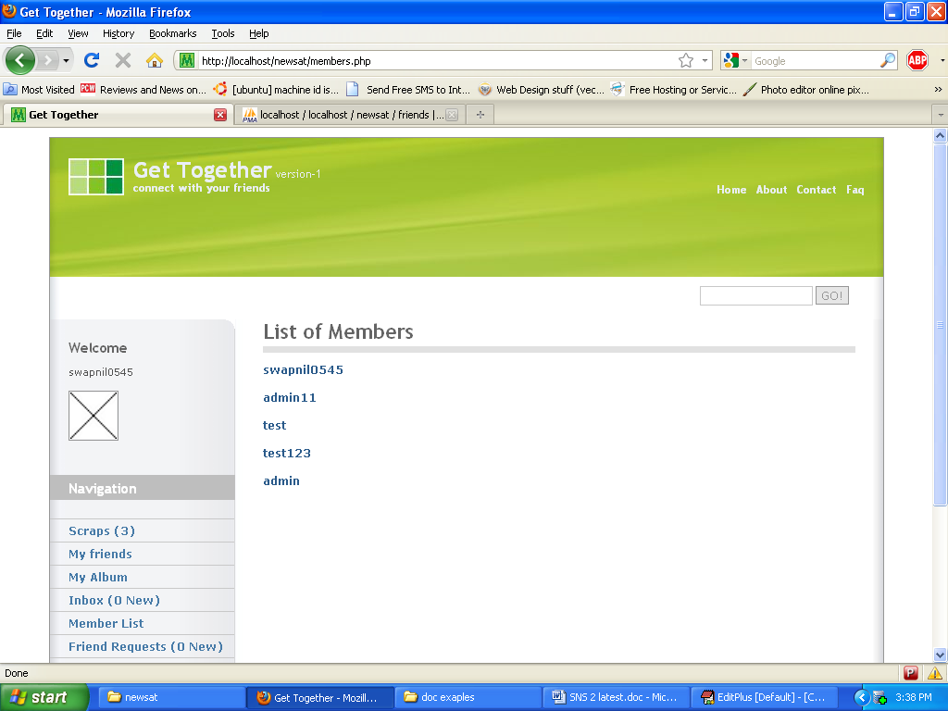

Name: Member List

Description: This page allows the user to view the members in the website.

9.1 Member Profile

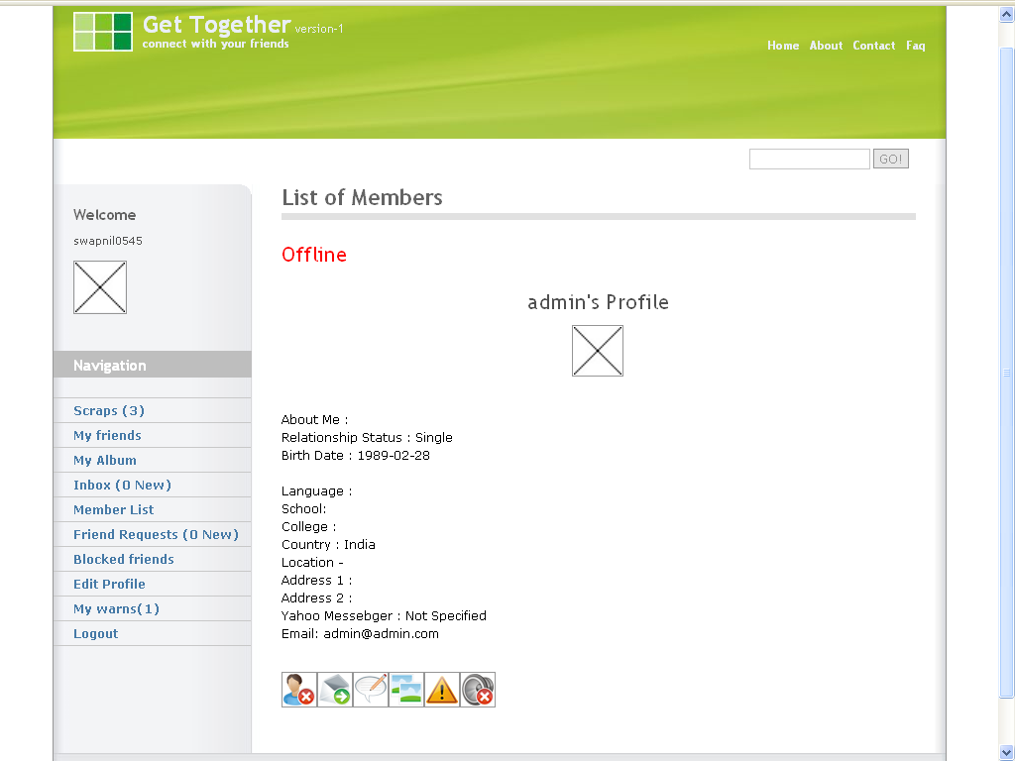
Name: Member Profile

Description: This page allows the user to view the profile of a member and also give them different options (add /remove a friend, send Private Message, Comment on their profile, Watch their Album, Report them bad user, and Block them from watching you)

Source Code of Member List and Profile
<?
include("config.php");
$page_title='List of Members';
include("includes/header.php");
include("includes/menu.php");
?>

<!-- B.1 MAIN CONTENT -->
<div class="main-content">

<!-- Pagetitle -->
<h1 class="pagetitle"> <?php echo "$page_title"; ?> </h1>
<?php if(!$logged['id']){
echo("<meta http-equiv=\"Refresh\" content=\"0; URL=index.php\"/>Thank You! You will be redirected");
}else{ // else if you are logged in then show the link

if (!$_GET[user])
{

$getuser = mysql_query("SELECT * from users order by id asc");
while ($user = mysql_fetch_array($getuser))
{// gets all the users information.
echo ("<p><a href=\"members.php?user=$user[id]\">$user[username]</a><br /></p>\n");
}// links to a page to view the user's profile.
}
ELSE
{
$getuser = mysql_query("SELECT * from users where id = '$_GET[user]'");
$usernum = mysql_num_rows($getuser);
if ($usernum == 0)
{
echo ("User Not Found");
}
else
{
$profile = mysql_fetch_array($getuser); //blocklist thing
$getfoe = mysql_query("SELECT * FROM `blocklist` WHERE `username` = '$profile[username]'");
$en = mysql_fetch_array($getfoe);
$getfriend = mysql_query("SELECT * FROM `friends` WHERE `friendname` = '$profile[username]' and `username` = '$logged[username]' OR `friendname` = '$logged[username]' and `username` = '$profile[username]' ");
$fa = mysql_fetch_array($getfriend);
$chkfoe = mysql_query("SELECT * FROM `blocklist` WHERE `foe` = '$profile[username]'");
$chk = mysql_fetch_array($chkfoe);
if ($logged[username] == $en[foe])
{
echo "<h1>$profile[username] has blocked you. </h1> <br />";
}
else{
if($profile[online]>= $offline) echo"<h1><font color='green'>Online</font></h1>";
else echo "<h1><font color='red'>Offline</font></h1>";
echo
("<h1 align='center'> $profile[username]'s Profile</h1>
<p class='center'>
<IMG class='center' SRC='http://$profile[picture]' height='48' width='48'><br />
<br /><p>
About Me : $profile[abtme]<br />
Relationship Status : $profile[rstats]<br />
Birth Date : $profile[dob]<br /><br />
Language : $profile[lang]<br />
School: $profile[scl]<br />
College : $profile[col]<br />
Country : $profile[ctry]<br />
");
if ($logged[username] != $profile[username])// check wether he is watching his own profile
{
if ($profile[username] == $fa[friendname] || $profile[username] == $fa[username])
{
echo "Location -<br />
Address 1 : $profile[add1]<br />
Address 2 : $profile[add2]<br />
Yahoo Messebger : $profile[yahoo]<br />
Email: $profile[email]<br /> <br /><p>
<a href='my_friends.php?page=delete&amp;user=$profile[username]'><img src='images/user_block.jpeg' border='0' title='Remove from friendlist' class='center'></a>";
echo "<a href='messages.php?page=write&user=$profile[username]'><img src='images/Mail.png' border='0' title='Send Message' class='center'></a></td></tr></table>";
echo "<a href='scrap.php?user=$profile[id]'><img src='images/Mail.png' border='0' title='Scraps' class='center'></a></td></tr></table>";
echo "<a href='gallery.php?user=$profile[id]'><img src='images/Mail.png' border='0' title='Album' class='center'></a></td></tr></table>";
echo "<a href='report.php'><img src='images/Mail.png' border='0' title='Report User' class='center'></a></td></tr></table>";
}else
{
echo "<a href='friendrequest.php?user=$profile[username]'><img class='center' src='images/user_add.jpeg' border='0' title='Add as friend'></a>";
echo "<a href='report.php'><img src='images/Mail.png' border='0' title='Report User' class='center'></a></td></tr></table>";
}
if ($profile[username] == $chk[foe])
{
echo "<a href='blocklist.php?page=delete&amp;user=$profile[username]'><img src='images/user_add.jpeg' border='0' title='Unblock user' class='center'></a>";
}else{
echo "<a href='blocklist.php?page=block&amp;user=$profile[username]'><img src='images/delete64.png' border='0' title='Block user' class='center'></a>";
}// in the above code, we display the user's information.
}}
}}}
?> </div>
<?include("includes/footer.php");?>

Make a friend Request
Friendrequest.php

<?
include "config.php"; //include config.
include "validate.php";
if ($logged[username])
{ //checks user is logged in
if ($_GET[user])
{ //gets username
$username = protect($_GET[user]); //friend
$by = $logged[username]; //you
$checkname = mysql_query("SELECT username,friendname FROM friends WHERE username='$by' AND friendname='$username'");
$check= mysql_num_rows($checkname);
if ($check>0) {
echo ("The friend is already added");
echo ("<meta http-equiv=\"Refresh\" content=\"1; URL=my_friends.php\"/>");
}else{
$query = mysql_query("INSERT INTO `friend_requests` ( `username` , `by` ) VALUES ( '$username' , '$by' )"); //inserts the request
echo("<p>$username has been sent a request you must now wait for it to be accepted</p>");
$id=mysql_query("SELECT * FROM users WHERE username='$username'");
$id=mysql_fetch_array($id);
echo ("<meta http-equiv=\"Refresh\" content=\"1; URL=members.php?user=$id[id]\"/>");
}
}else{ echo("<p>No request was made</p>"); }
}
else {
echo ("<p>You need to be logged in</p>");
}
?>

Report.php
<?
include("config.php");
include("validate.php");
$page_title='Report';
include("includes/header.php");
include("includes/menu.php");
?>
<!-- B.1 MAIN CONTENT -->
<div class="main-content">

<!-- Pagetitle -->
<h1 class="pagetitle"> <?php echo "$page_title"; ?> </h1>
<?php
if(!$logged['username']){//check for logged username
echo "<h2>Error</h2>
<p>
You Are Not Logged In
</p>"; //they aren't so give err
}else{ //or
if(!$_POST['report']){ //form wasn't submitted
echo "<div class='contactform'><h2>Report User</h2>
<form method=\"post\" action=\"$_SERVER[PHP_SELF]\">
<p>
<label class='left'>Username</label>
<input type=\"text\" name=\"user\" size=\"30\" /><br /><br />
<label class='left'>Reason</label>
<textarea cols=\"25\" rows=\"5\" name=\"reason\"></textarea><br/>
<input type=\"submit\" name=\"report\" value=\"Report User\" class='button' />
</p>
</form>"; //give the form to report someone :)
}else{ //or...
$user = protect($_POST['user']); //protect the username being reported
$reason = protect($_POST['reason']); //protect the text input again
$date = date("d-m-y h:i A"); //today's date
$from = $logged['username']; //logged user :)
$checkuser = mysql_query("select * from`users` where `username`='$user'");
$checkuser = mysql_fetch_array($checkuser);
if(empty($user) || empty($reason)){ //something was empty!!!!
echo "<h2>Error</h2>
<p>
You Must Fill Out The Form Completely
</p>"; //haha you fail!
}else{ //or not?
if($checkuser>0){
$insert = mysql_query("INSERT INTO `reps` (`username`,`reason`,`date`,`reported_by`) VALUES ( '$user','$reason','$date','$from');"); //insert the data

echo "<h2>Success</h2>
<p>
Report Sent!
</p>"; //no error
}else{echo "<h2>Enter a Valid Username</h2>
<p>" . mysql_error() . "</p>"; }//echo the error
//end error check
} //end empty check
}//end form check
} //end logged in check
?>
</div> </div>

<?include("includes/footer.php");?>

10. Friend Request

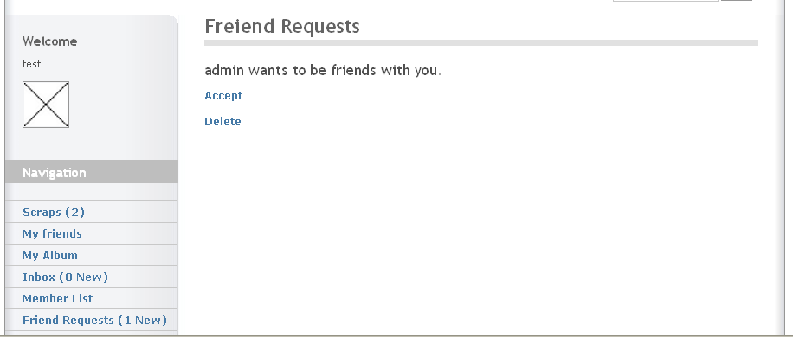

Name: Friend Request

Description: This page allows the user to accept or delete the friends request made by the new user.

Source Code of Friend Request

Newfriends.php

<?
include "config.php"; // inlcudes config
$page_title='Freiend Requests';
include("includes/header.php");
include("includes/menu.php");
?>
<!-- B.1 MAIN CONTENT -->
<div class="main-content">
<!-- Pagetitle -->
<h1 class="pagetitle"> <?php echo "$page_title"; ?> </h1>
<div class="column1-unit">
<?php
if ($logged[username]) { //checks user is logged in
switch ($_GET[friends]) { //allows multiple pages
default:
$get = mysql_query( "SELECT * FROM `friend_requests` WHERE `username` = '$logged[username]' "); //gets requests
if ($reqs = mysql_fetch_array($get)){
echo ( "<h2>$reqs[by] wants to be friends with you.</h2>
<p><a href='newfriends.php?friends=accept&user=$reqs[by]'>Accept</a></p>
<p><a href='newfriends.php?friends=delete&user=$reqs[by]'>Delete</a></p>" ); //displays requests and shows accept delete links
}else echo ("You have no New friend requests");
break;
case 'accept': //accept page
if ($_GET[user]) { //get username
$add = mysql_query( "INSERT INTO `friends` (`friendname` , `username`) VALUES ('$_GET[user]' , '$logged[username]') ");
$add = mysql_query( "INSERT INTO `friends` (`username` , `friendname`) VALUES ('$_GET[user]' , '$logged[username]') ");// add to your friends list
$delete = mysql_query( "DELETE FROM `friend_requests` WHERE `by` = '$_GET[user]' "); // deletes friend request
echo ( "$_GET[user] has been added as a friend and the request has been deleted" ); // echos the completion
}
break; //ends accept page
case 'delete': // delete page
if ($_GET[user]) { //gets username
$delete = mysql_query( "DELETE FROM `friend_requests` WHERE `by` = '$_GET[user]' "); // deletes friend request
echo ( "$_GET[user]'s request has been deleted" ); // echos completion
}
break; //ends delete page
} // ends switch
}else{
echo ( "You need to be logged in" ); // not logged in
}
?>
</div></div>
<?include("includes/footer.php");?>

11. Blocked Users

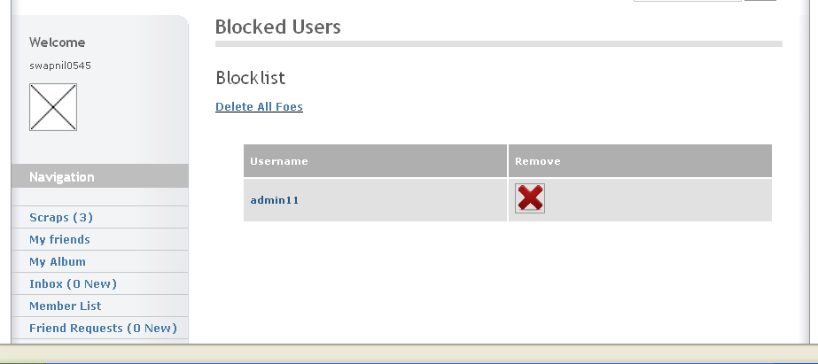

Name: Blocked User

Description: This page allows the user to view the blocked user blocked by them.

Source Code of Blocked Users

<?php
include ('config.php');
$page_title='Blocked Users';
include ('includes/header.php');
include ('includes/menu.php');
?>
<!-- B.1 MAIN CONTENT -->
<div class="main-content">
<!-- Pagetitle -->
<h1 class="pagetitle"> <?php echo "$page_title"; ?> </h1>
<?
if(!$logged['id']){
echo "You need to be logged in to post a comment! <a href='index.php'>Login Here!</a>";
} // else if you are logged in then show the link.
else{
switch($_GET[page]){ //make some links ?page=case
case 'deleteall': // delete page
$delete = mysql_query( "DELETE FROM `blocklist` WHERE `username` = '$logged[username]' "); // deletes friend request
echo ( "You have unblocked all your foes." ); // echos completion
break; //ends delete page
case 'block': // delete page
if ($_GET[user]){ //gets username
$thefoe = htmlspecialchars($_GET[user]); //friend
$query = mysql_query("INSERT INTO `blocklist` ( `username` , `foe` ) VALUES ( '$logged[username]' , '$thefoe' )"); //inserts the request
echo ( "You have blocked $thefoe. They cannot send you PMs anymore." ); // echos completion
}
break;
case 'delete': // delete page
if ($_GET[user]) { //get username
$delete = mysql_query( "DELETE FROM `blocklist` WHERE `foe` = '$_GET[user]' "); // deletes friend request
echo ( "$_GET[user] has been unblocked." ); // echos completion
}
break; //ends delete page
default: //set up the default page upon going to inbox.php
$afed = mysql_query("SELECT * FROM `blocklist` WHERE `username` = '$logged[username]' ORDER BY `id` ASC") or die(mysql_error());
//loops there name out
echo "<h1>Blocklist</h1>
<p><u><a href='?page=deleteall'>Delete All Foes</a></u></p><center>
<table align=center>
<tr align='center' id='top'>
<th class='top' scope='col'>Username</th>
<th class='top' scope='col' >Remove</th></tr>";
$get = mysql_query("SELECT * FROM `blocklist` WHERE `username` = '" . $logged[username] . "'"); //get the private messages
$enemys = mysql_query("SELECT * FROM `blocklist` WHERE `username` = '$logged[username]' ORDER BY `id` ASC") or die(mysql_error());
if(mysql_num_rows($get) == "0"){
echo "<tr align='center'><td colspan='2'>You Have No Enemies!</td></tr></table>";
}else{
while ($e = mysql_fetch_array($enemys)) {
$fid = mysql_query("SELECT * FROM `users` WHERE `username` = '$e[foe]'") or die(mysql_error());
$fri = mysql_fetch_array($fid);
echo "<tr align='center'><td><a href='members.php?user=$fri[id]'>$e[foe]</a></td><td><a href='?page=delete&amp;user=$e[foe]'><img src='images/delete64.png' border='0' title='Unblock User'></a></td></tr>";
}
echo "</table></center>";
}
break;
}
}
?>
</div>
<?include("includes/footer.php");?>

12. My Friends

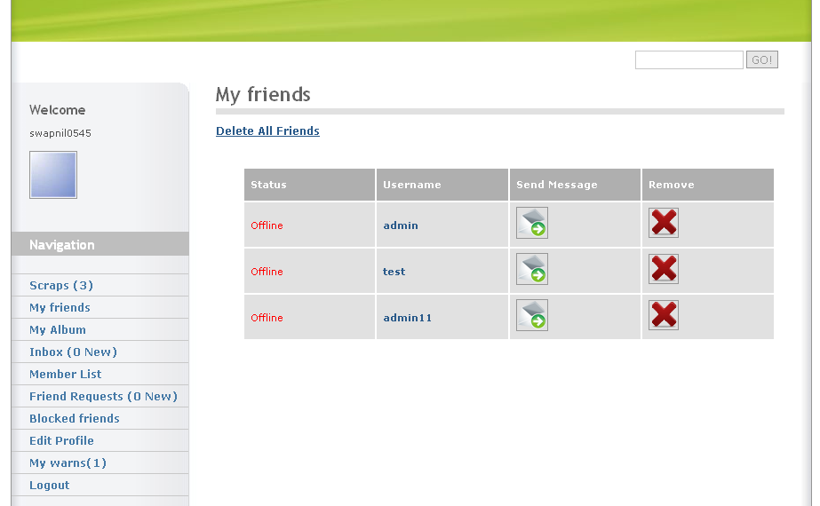

Name: My Friends

Description: This page allows the user to view his/her current friend and also to send them a private message or remove them from their friend’s list.

Source Code of My Friends

<?
include("config.php");
$page_title='My friends';
include("includes/header.php");
include("includes/menu.php");
?>
<!-- B.1 MAIN CONTENT -->
<div class="main-content">
<!-- Pagetitle -->
<h1 class="pagetitle"> <?php echo "$page_title"; ?> </h1>
<?
//check user is logged in or not
if (!$logged["username"]) {
echo ("<meta http-equiv=\"Refresh\" content=\"1; URL=login.php\"/>Thank You! You will be redirected");
exit;
}
switch($_GET[page]){ //make some links ?page=case
case 'deleteall': // delete page
$delete = mysql_query( "DELETE FROM `friends` WHERE `username` = '$logged[username]' "); // deletes friend request
echo ( "You have deleted all your friends." ); // echos completion
break; //ends delete page
case 'delete': // delete page
if ($_GET[user]) { //get username
$delete = mysql_query( "DELETE FROM `friends` WHERE `friendname` = '$_GET[user]' "); // deletes friend request
echo ( "$_GET[user] has been deleted from your friendlist." ); // echos completion
}
break; //ends delete page
default: //set up the default page upon going to inbox.php
$afed = mysql_query("SELECT * FROM `friends` WHERE `username` = '$logged[username]' OR 'friendname' = '$logged[username]' ORDER BY `id` ASC") or die(mysql_error());
//loops there name out
echo "<p>
<a href='?page=deleteall'><u>Delete All Friends</u></a></p><center>
<table align=center>
<tr align='center' id='top'>
<th class='top' scope='col'>Status</th>
<th class='top' scope='col'>Username</th>
<th class='top' scope='col'>Send Message</th>
<th class='top' scope='col'>Remove</th></tr>";
while ($fr = mysql_fetch_array($afed)) {
$fid = mysql_query("SELECT * FROM `users` WHERE `username` = '$fr[friendname]' ") or die(mysql_error());
$fri = mysql_fetch_array($fid);
echo "<tr align='center'>
<td> "; if($fri[online]>= $offline) echo"<font color='green'>Online</font>";
else echo "<font color='red'>Offline</font>";
echo "</td>
<td><a href='members.php?user=$fri[id]'>$fr[friendname]</a></td>
<td><a href='messages.php?page=write&;page=msgto&amp;user=$fri[username]'>
<img src='images/Mail.png' border='0' title='Send Message'></a></td>
<td><a href='?page=delete&amp;user=$fr[friendname]'>
<img src='images/delete64.png' border='0' title='Remove Friend?'></a></td>
</tr>";
}
echo "</table></center>";
break;
}
?>
</div>
<?include("includes/footer.php");?>

13. Edit Profile

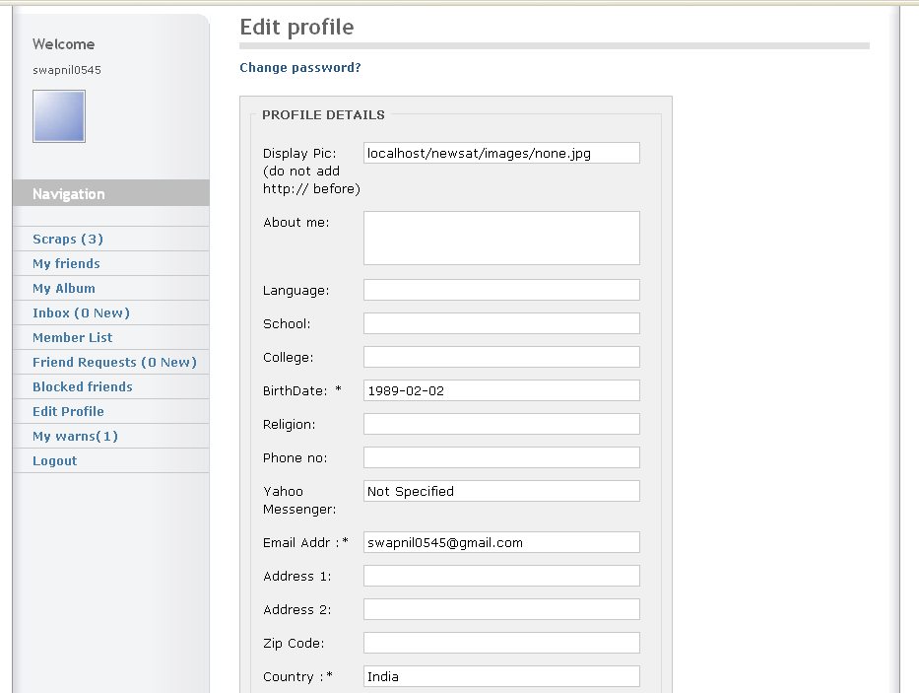
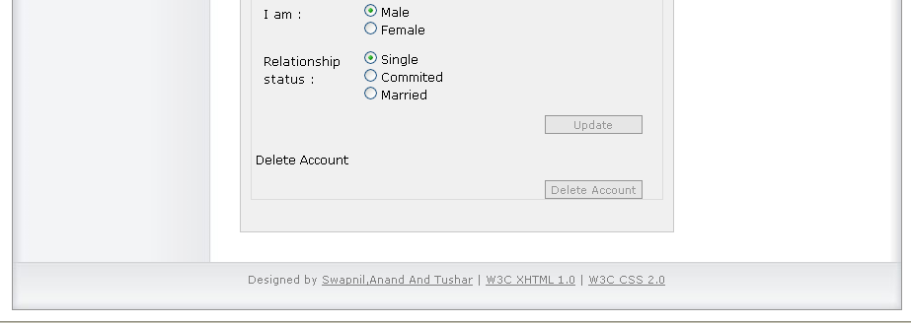

Name: Edit Profile

Description: This page allows the user to edit their profile, change their password and to delete their account.

Source Code of Edit Profile

Editprofile.php

<?
include("config.php");
include("validate.php");
$page_title='Edit profile';
include("includes/header.php");
include("includes/menu.php");
?>
<!-- B.1 MAIN CONTENT -->
<div class="main-content">
<!-- Pagetitle -->
<h1 class="pagetitle"> <?php echo "$page_title"; ?> </h1>
<?php
if ($logged[username]){
if($_POST['deleteid']){
$del = $_POST['delid'];
$del= MYSQL_QUERY("SELECT * from users WHERE id='$del'");
$del = mysql_fetch_array($del);
echo ("<h1>Warning! your account will be deleted</h1>");
echo ("Are you sure! You want to delete your account.<br>All your details will be deleted");
echo ("<form action='editprofile.php?user=$del[id]' method='POST'>
<input type='hidden' name='delid' value='$del[id]' />
<select name='confirm'>
<option value='yes'> YES</option>
<option value='no'> No </option></select>
<input type='submit' name='deleteid' value='confirm' class='button'/>
</form> ");
$conf = $_POST['confirm'];
if($conf=='yes'){
echo (" $del[id] $del[username] $del ");
$update=mysql_query("DELETE FROM `users` Where id=$del[id]");
$update=mysql_query("DELETE FROM `pmessages` Where touser=$del[username]");
$update=mysql_query("DELETE FROM `members_comments` Where member_id=$del[id]");
$update=mysql_query("DELETE FROM `friend_requests` Where username=$del[username]");
$update=mysql_query("DELETE FROM `friends` Where username='$del[username]' OR friendname='$del[username]'");
$update=mysql_query("DELETE FROM `blocklist` Where username=$del[username]");
$update=mysql_query("DELETE FROM `album` Where userid=$del[id]");
echo ("<meta http-equiv=\"Refresh\" content='4; url=index.php'/>Account deleted ");}
}//delete post complete
if (!$_POST[update])
{// the form hasn't been submitted. We continue...
$profile = mysql_query("SELECT * from users where username = '$logged[username]'");
$profile = mysql_fetch_array($profile);
// the above lines get the information so that it can be displayed in the html form.
echo("<p>
<a href='changepassword.php' title='Changepass'>Change password?</a></p>
<div class='contactform'>
<fieldset><legend>&nbsp;PROFILE DETAILS&nbsp;</legend>
<form method=\"POST\">
<p><label class='left'>Display Pic: (do not add http:// before) </label>
<input type='text' size=\"25\" class='field' name=\"picture\" value=\"$profile[picture]\" /></p>
<p><label class='left'>About me:</label>
<textarea size=\"25\" class='field' name=\"abtme\" value='$profile[abtme]'>$profile[abtme]</textarea></p>
<p><label class='left'>Language:</label>
<input type='text' size=\"25\" class='field' name=\"lang\" value=\"$profile[lang]\" /></p>
<p><label class='left'>School:</label>
<input type='text' size=\"25\" class='field' name=\"scl\" value=\"$profile[scl]\" /></p>
<p><label class='left'>College:</label>
<input type='text' size=\"25\" class='field' name=\"col\" value=\"$profile[col]\" /></p>
<p><label class='left'>BirthDate: *</label>
<input type='text' size=\"25\" class='field' name=\"dob\" value=\"$profile[dob]\" /></p>
<p><label class='left'>Religion:</label>
<input type='text' size=\"25\" class='field' name=\"rlgn\" value=\"$profile[rlgn]\"/></p>
<p><label class='left'>Phone no:</label>
<input type='text' size=\"25\" class='field' name=\"pno\" value=\"$profile[pno]\" /></p>
<p><label class='left'>Yahoo Messenger:</label>
<input type='text' size=\"25\" class='field' name=\"yahoo\" value=\"$profile[yahoo]\" /></p>
<p><label class='left'>Email Addr :*</label>
<input type='text' size=\"25\" class='field' name=\"email\" value=\"$profile[email]\" /></p>
<p><label class='left'>Address 1:</label>
<input type='text' size=\"25\" class='field' name=\"add1\" value=\"$profile[add1]\" /></p>
<p><label class='left'>Address 2:</label>
<input type='text' size=\"25\" class='field' name=\"add2\" value=\"$profile[add2]\" /></p>
<p><label class='left'>Zip Code:</label>
<input type='text' size=\"25\" class='field' name=\"zipc\" value=\"$profile[zipc]\" /></p>
<p><label class='left'>Country :*</label>
<input type='text' size=\"25\" class='field' name=\"ctry\" value=\"$profile[ctry]\" /></p>
<p>
<label for='gender' class='left'>I am :</label> ");
switch($profile[gender]){
case Male:
echo"<input type='radio' name='gender' value='Male' checked='checked'/> Male<br />
<input type='radio' name='rstats' value='Female' /> Female<br />";
break;
case Female:
echo"<input type='radio' name='gender' value='Male'/> Male<br />
<input type='radio' name='rstats' value='Female' checked='checked'/> Female<br />";
break;
default:
echo"<input type='radio' name='gender' value='Male'/> Male<br />
<input type='radio' name='rstats' value='Female'/> Female<br />";
}
echo("
</p>
<p>
<label for='rstats' class='left'>Relationship status :</label> ");
switch($profile[rstats]){
case Single:
echo"<input type='radio' name='rstats' value='Single' checked='checked'/> Single<br />
<input type='radio' name='rstats' value='Committed' /> Commited<br />
<input type='radio' name='rstats' value='Married' /> Married<br />";
break;
case Committed:
echo"<input type='radio' name='rstats' value='Single' /> Single<br /><input type='radio' name='rstats' value='Committed' checked='checked'/> Committed<br /><input type='radio' name='rstats' value='Married' /> Married<br />";
break;
case Married:
echo"<input type='radio' name='rstats' value='Single' /> Single<br />
<input type='radio' name='rstats' value='Committed' /> Commited<br /><input type='radio' name='rstats' value='Married' checked='checked'/> Married<br />";
break;
default:
echo"<input type='radio' name='rstats' value='Single' /> Single<br />
<input type='radio' name='rstats' value='Committed' /> Commited<br /><input type='radio' name='rstats' value='Married'/> Married<br />";
break;
}
echo("
</p>
<input type=\"submit\" name=\"update\" class='button' value=\"Update\">
</form>
<br/><br/><br/>
<p>&nbsp;Delete Account&nbsp;</p>
<form action='editprofile.php?user=$profile[id]' method='POST'>
<input type='hidden' name='delid' value='$profile[id]' />
<input type='submit' name='deleteid' value='Delete Account' class='button'/>
</form>
</fieldset>
<br/>
</div>");
}
else
{
$picture = protect($_POST[picture]);
$abtme = protect($_POST[abtme]);
$lang = protect($_POST[lang]);
$scl = protect($_POST[scl]);
$col = protect($_POST[col]);
$dob = protect($_POST[dob]);
$rlgn= protect($_POST[rlgn]);
$pno = protect($_POST[pno]);
$yahoo = protect($_POST[yahoo]);
$email = protect($_POST[email]);
$add1 = protect($_POST[add1]);
$add2 = protect($_POST[add2]);
$zipc = protect($_POST[zipc]);
$ctry = protect($_POST[ctry]);
$gender= protect($_POST[gender]);
$rstats = protect($_POST[rstats]);
if($picture!=NULL){
if(validateUrl($picture)){
$update = mysql_query("Update users set picture = '$picture' where username = '$logged[username]'");
}else echo "Enter a Valid URL eg. - google.com/image.jpg";}
if($yahoo=NULL){
if(validateyahoo($yahoo)){
$update = mysql_query("Update users set yahoo = '$yahoo' where username = '$logged[username]'");
}else echo "1Enter Proper email address eg.abc@domain.com";}
if(validateEmail($email)){
$update = mysql_query("Update users set email = '$email' where username = '$logged[username]'");
}else echo "2Enter Proper email address eg.abc@domain.com";
if($pno!=NULL){
if(validatephone($pno)){
$update = mysql_query("Update users set pno = '$pno' where username = '$logged[username]'");
}else echo "<h1>Enter a Valid Phone. It can contain only numbers.</h1>";}
if($zipc!=NULL){
if(validatezipc($zipc)){
$update = mysql_query("Update users set zipc = '$zipc' where username = '$logged[username]'");
}else echo "<h1>Invalid Zip Code. </h1>";}
$Agediff=GetAge($dob);
If($Agediff>8 && $Agediff<101){
$update = mysql_query("Update users set dob = '$dob' where username = '$logged[username]'");
}else
{
echo "<h1>Enter a Valid Date Of Birth.</h1>";
}
if($dob==NULL|$email==NULL|$ctry==NULL)
{
echo ("<meta http-equiv='Refresh' content='2; url=editprofile.php'/>
<h1>Date of Birth,Email Address and Country cannot be nulled</h1>");
}
else{
// the above lines get rid of all html.
$update = mysql_query("Update users set abtme = '$abtme',lang = '$lang',scl = '$scl',
col = '$col',dob = '$dob',rlgn = '$rlgn',add1 = '$add1',add2 = '$add2',ctry = '$ctry',gender = '$gender',rstats = '$rstats' where username = '$logged[username]'");
echo ("<meta http-equiv=\"Refresh\" content='2; url=editprofile.php'/><h1>Your profile has been updated!</h1>");
// updates the information in the database.
}
}
}else{ echo("<a href=\"login.php\">You must login</a>");
}
?>
</div>
<?include("includes/footer.php");?>

14. Change Password

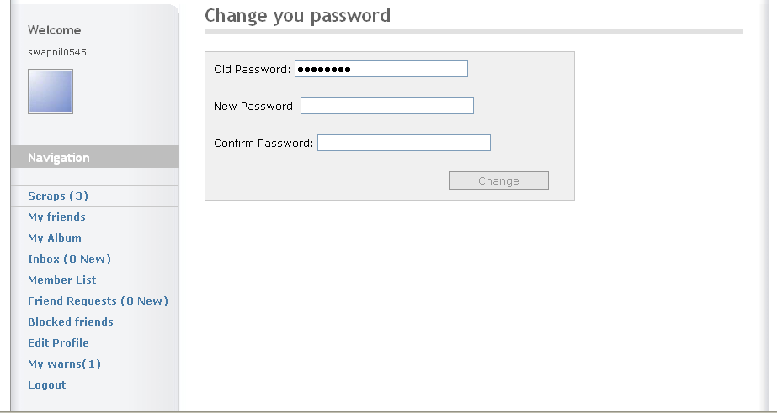

Name: Change Password

Description: This page allows the user to change their current password.

Source Code of Change Password

Changepassword.php
<?
include("config.php");
$page_title='Change you password';
include("includes/header.php");
include("includes/menu.php");
?>
<!-- B.1 MAIN CONTENT -->
<div class="main-content">
<!-- Pagetitle -->
<h1 class="pagetitle"> <?php echo "$page_title"; ?> </h1>
<?php
//checks see if there logged in
if($logged[id]){
if(isset($_GET['update'])) {
//posts the passwords
$oldpassword = md5($_POST[oldpassword]);
$newpassword = md5($_POST[newpassword]);
$cnewpassword = md5($_POST[cnewpassword]);
//get the users old info from the database
$info = mysql_query("SELECT * FROM `users` WHERE `username` = '$logged[username]'");
$info = mysql_fetch_array($info);
//if the old password matches the password in the database we continue
if($info[password] == $oldpassword) {
//if the new password and conformation password are the same continue
if($newpassword == $cnewpassword) {
$update = mysql_query("UPDATE `users` SET `password` = '$newpassword' WHERE `username` = '$logged[username]'");
echo "Password Updated, You will need to relogin with your new password.";
unset($_SESSION['id']);
unset($_SESSION['password']);
}else{ echo ("Your new password and conformation password do not match!"); }
}else{echo ("Your old password does not match the database password!"); }
}else{ //shows the form if not already updated
echo ("<div class='contactform'><form action='changepassword.php?update' method='post'>
<p>Old Password: <input type='password' name='oldpassword' size='30' maxlength='50'></p><br>
<p>New Password: <input type='password' name='newpassword' size='30' maxlength='50'></p><br>
<p>Confirm Password: <input type='password' name='cnewpassword' size='30' maxlength='50'></p><br>
<p><input type='submit' value='Change' class='button'></p>
</form</div>");
}
}else{echo("You are not logged in.");}
?>
</div>
<?include("includes/footer.php");?>

15. My Warns

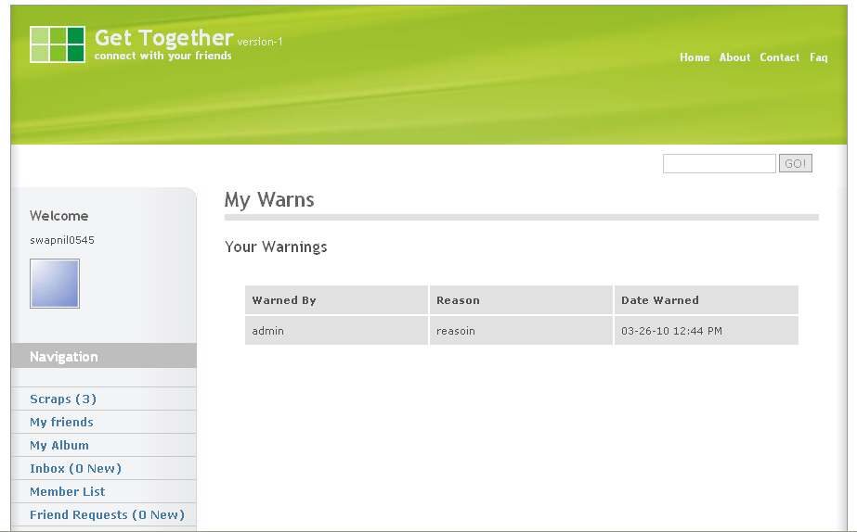

Name: Warns

Description: This page allows the user to view number of warnings given to him/her by the Admin.

Source Code of Warns
<?
include("config.php");
$page_title='My Warns';
include("includes/header.php");
include("includes/menu.php");
?>
<!-- B.1 MAIN CONTENT -->
<div class="main-content">
<!-- Pagetitle -->
<h1 class="pagetitle"> <?php echo "$page_title"; ?> </h1>
<?php
if(!$logged['username']){ //not logged in
echo ("<h2>Error</h2><p>You Are not Logged In</p>"); //lol error
}else{ //or they are
echo ("<h2>Your Warnings</h2>
<table width=\"400\">
<tr>
<td align=\"left\" valign=\"middle\">
<b>Warned By</b>
</td>
<td align=\"left\" valign=\"middle\">
<b>Reason</b>
</td>
<td align=\"left\" valign=\"middle\">
<b>Date Warned</b>
</td>
</tr>"); //table headers
$get_warns = mysql_query("SELECT * FROM `warnings` WHERE `user` = '$logged[username]';"); //get the users warns
while($warns = mysql_fetch_array($get_warns)){ //loop them
echo ("<tr>
<td align=\"left\" valign=\"middle\">
$warns[from]
</td>
<td align=\"left\" valign=\"middle\">
$warns[reason]
</td>
<td align=\"left\" valign=\"middle\">
$warns[date]
</td>
</tr>"); //display their warns
} //end loop
echo ("</table>"); //end table
}
?> </div> <?include("includes/footer.php");?>

16. Search User

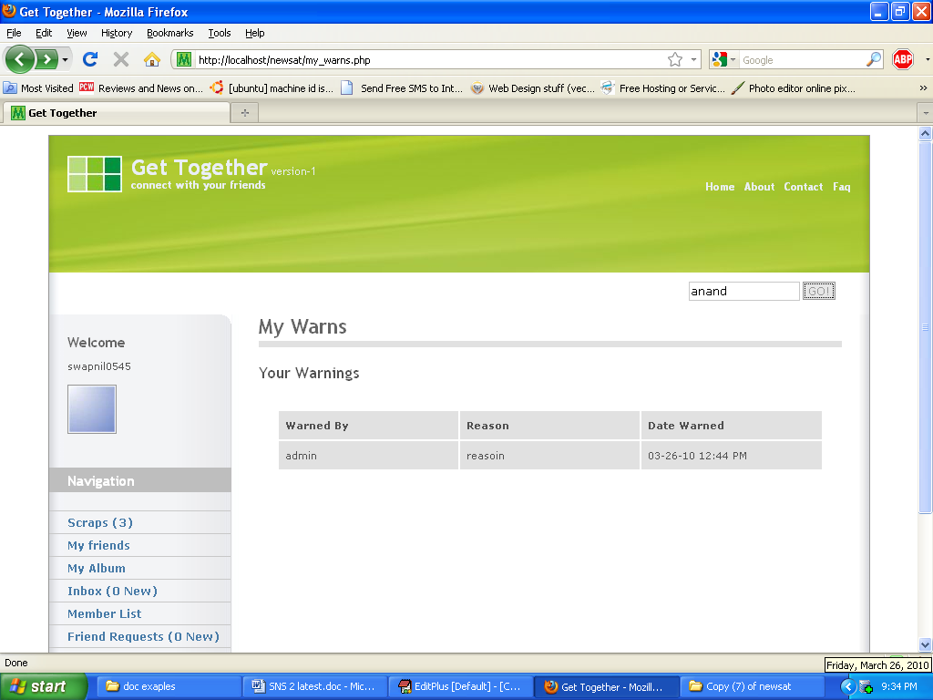

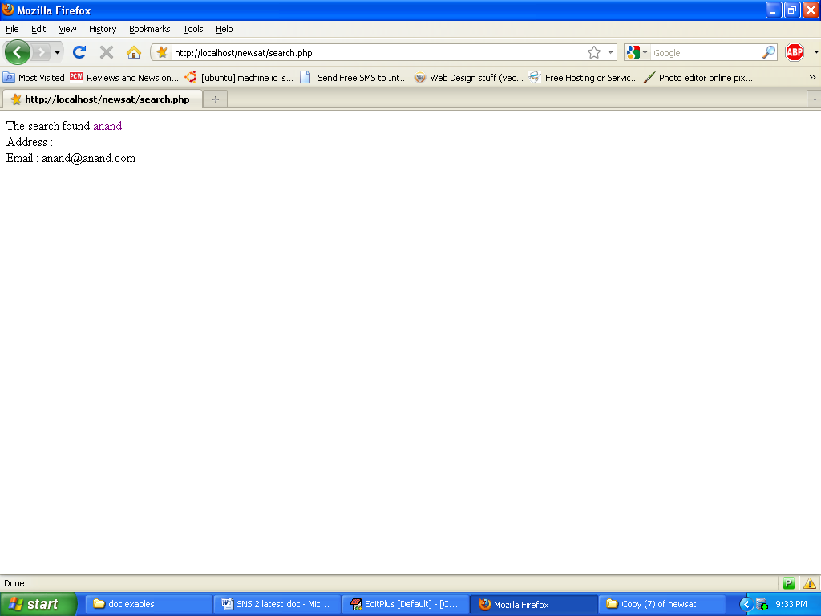

Name: Search User

Description: This page allows the user to search the users and to view their address alond with their email id.

Source Code of Search User
Search.php
<?php
//the config file should connect to mysql.
require("config.php");
//select database
mysql_select_db("users");
$search = $_POST["search"];
//assigns the value of the entered search term in to the variable "search"
$result = mysql_query("SELECT * FROM users where username LIKE '%$search%'");
$num = mysql_num_rows($result);
//note "username" would be the field the search looks up, so if you searched for "Waffles" it would look up waffles username in the table users.
while($r=mysql_fetch_array($result))
//grabs all the content it found
{
//then change this to match your mysql columns..this will be the information displayed. You could just have username.
$id=$r["id"];
$username=$r["username"];
$email=$r["email"];
//and so on
// then just display the row
echo "<p>The search found <a href=\"members.php?user=$id\">$username</a>
<br/> Address : $r[add1]
<br/> Email : $email</p><br>";
}
if($num==0)
{
echo("<font size='4' color='grey'>
No users having <font color='blue'>$search</font> in the username were found.
</font> ");
include 'members.php'; //if you want this one go ahead. I just put it so it helps the users searching. it will list the members.
}
?>

17. Reports Panel

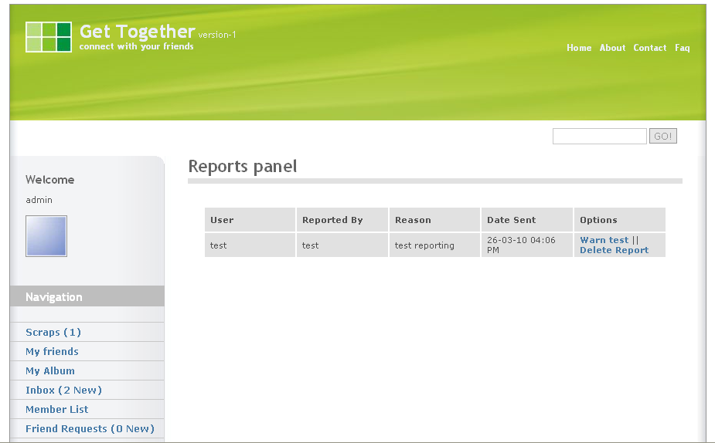

Name: Reports Panel

Description: This page allows the Admin to view the Reports made by the user of particular user.

Source Code of Reports Panel

Repcp.php
<?
include("config.php");
include("validate.php");
$page_title='Reports panel';
include("includes/header.php");
include("includes/menu.php");
?>
<!-- B.1 MAIN CONTENT -->
<div class="main-content">
<!-- Pagetitle -->
<h1 class="pagetitle"> <?php echo "$page_title"; ?> </h1>
<?php
if(!$logged['username']){ //check logged user
echo("<h2>Error</h2> <p> You Are Not Logged In! </p>"); //nope
}elseif($logged['username'] && $logged['level'] < '5'){ //not an admin or mod
echo("<h2>Error</h2> <p>You Do Not Have Access to this Function. </p>"); //give error >:|
}else{ //or they are :D
switch($_GET['x']){ //make multiple pages
default: //default
$get_reps = mysql_query("SELECT * FROM `reps` ORDER BY `id` DESC"); //get all reports
if(mysql_num_rows($get_reps) == 0){ //none >:(
echo("<h2>No Reports</h2> <p> There are No Reports in the Database. </p>"); //woohoo error!!
}else{ //or not >)
echo("<table width='00'>
<tr>
<td align='left' valign='middle'>
<b>User</b>
</td>
<td align='left' valign='middle'>
<b>Reported By</b>
</td>
<td align='left'valign='middle'>
<b>Reason</b>
</td>
<td align='left' valign='middle'>
<b>Date Sent</b>
</td>
<td align='center' valign='middle'>
<b>Options</b>
</td>
</tr>"); //table headers
while($reps = mysql_fetch_array($get_reps)){ //make a loop for the reports to be shown
echo("<tr>
<td align='left' valign='middle'>
$reps[username]
</td>
<td align='left' valign='middle'>
$reps[reported_by]
</td>
<td align='left' valign='middle'>
$reps[reason]
</td>
<td align='left' valign='middle'>
$reps[date]
</td>
<td align='left' valign='middle'>
<a href=\"repcp.php?x=warn&id=$reps[id]\">Warn $reps[username]</a>&nbsp;||&nbsp;
<a href=\"repcp.php?x=delete&id=$reps[id]\">Delete Report</a>
</td>
</tr>"); //yay for data to be shown :)
} //end the loop :(
} //end the reports check
break; //end the default page
case 'warn': //haha i get to warn the dude >:)
$id = (int) addslashes($_GET['id']); //make the ID Safe
if(!$id){ //no id sucker!
echo("<h2>Error</h2>
<p>
No ID Selected
</p>"); //haha you got an error
}else{ //or not :(
$check = mysql_query("SELECT * FROM `reps` WHERE `id` = '$id';"); //check to make sure
if(mysql_num_rows($check) == 0){ //lol you still got an error >:)
echo("<h2>Error</h2>
<p>
Invalid ID Selected.
</p>"); //give him/her what they came for!
}else{ //or not...
$array = mysql_fetch_array($check); //array the data
if(!$_POST['warn']){ //warn form wasn't submitted
echo("<h2>Warn $array[username]</h2>
<form method='post' action='$_SERVER[PHP_SELF]?x=warn&id=$id'>
<p>
<label>Reason</label>
<textarea rows='5' cols='25' name='reason'></textarea>
<input type=\"submit\" name=\"warn\" value=\"Warn $array[username]\">
</p>
</form>"); //give the reasoning form :)
}else{ //chyea the form was submitted
$reason = protect($_POST['reason']); //make the reason safe
$date = date("m-d-y h:i A"); //the date
$from = $logged['username']; //who warned
if(empty($reason)){ //reason was empty
echo("<h2>Error</h2> <p> You Must Give A Reason
</p>"); //lol you got an error
}else{ //darn. your not.
$insert = mysql_query("INSERT INTO `warnings` (`user`,`reason`,`from`,`date`) VALUES ('$array[username]','$reason','$from','$date');"); //warn the user
$delete = mysql_query("DELETE FROM `warnings` WHERE `id` = '$id';"); //delete the report
if(!mysql_error()){ //no mySQL Error
echo("<h2>Success</h2> <p> $array[user] Has Been Warned! </p>"); //yay they were warned!
}else{ //or not
echo("<h2>Error</h2> <p> ".mysql_error()." </p>"); //HAHA YOU GOT AN ERROR
} //end error check
} //end empty form check
} //end the form submit check
} //end the verification check
} //end the final check if id is there or not xD
break;
case 'delete': //the delete report page >:)
$id = (int) addslashes($_GET['id']); //make the ID safe
if(!$id){ //no id HAHA
echo("<h2>Error</h2> <p>No ID Selected </p>"); //lol you got an error
}else{ //there was an id D:
$check = mysql_query("SELECT * FROM `reps` WHERE `id` = '$id';"); //check DB for ID
if(mysql_num_rows($check) == 0){ //haha not found
echo("<h2>Error</h2>
<p>
Invalid ID Selected
</p>"); //invalid ID
}else{ //its found :) :(
$delete = mysql_query("DELETE FROM `reps` WHERE `id` = '$id';"); //delete it
if(!mysql_error()){ //no error
echo("<h2>Success</h2>
<p>
Report Deleted
</p>"); //yay!!
}else{ //or not....
echo("<h2>Error</h2>
<p>
".mysql_error()."
</p>"); //you got an error
} //end error check
} //end verification check
} //end first id check
break; //end the page
}//end the switch function
} //end logged username check
?>

18. Edit Users Profile

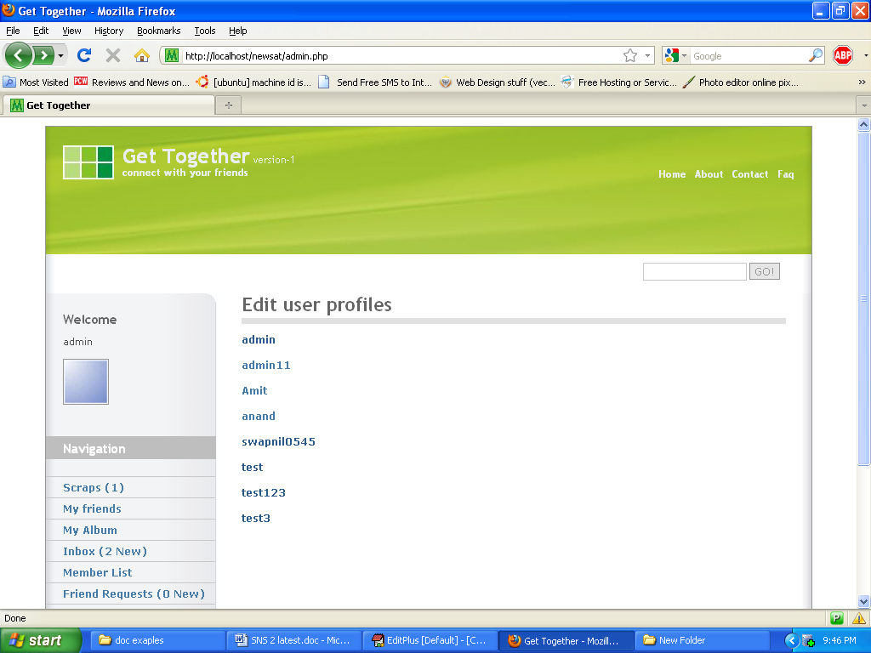

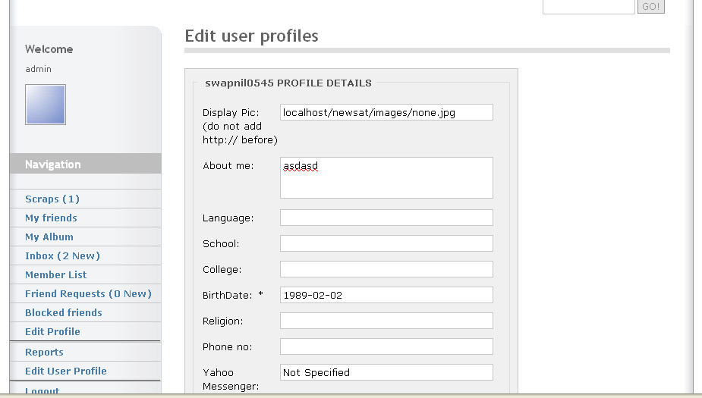
Name: Edit Users Profile

Description: This page allows the Admin to change the profile of the Reported users.

Source Code of Edit Users Profile

<?
include("config.php");
include("validate.php");
$page_title='Edit user profiles';
include("includes/header.php");
include("includes/menu.php");
?>
<!-- B.1 MAIN CONTENT -->
<div class="main-content">
<!-- Pagetitle -->
<h1 class="pagetitle"> <?php echo "$page_title"; ?> </h1>
<?php
if($logged[username] && $logged[level] ==5)
{
//checks to see if the user is logged in, and if their user level
//is 5 (this is administrator)
if($_GET[user])
{
//checks to see if there is a ?user=username variable in the url.
if (!$_POST[update])
{
// the form hasn't been submitted. We continue...
$profile = mysql_query("SELECT * from users where username = '$_GET[user]'");
$profile = mysql_fetch_array($profile);
//these lines get the user's information and put it in an array.
//we will display the information in the html form
echo("
<div class='contactform'>
<fieldset><legend>&nbsp; $profile[username] PROFILE DETAILS&nbsp;</legend>
<form method=\"POST\">
<p><label class='left'>Display Pic: (do not add http:// before) </label>
<input type='text' size=\"25\" class='field' name=\"picture\" value=\"$profile[picture]\" /></p>
<p><label class='left'>About me:</label>
<textarea size=\"25\" class='field' name=\"abtme\" value='$profile[abtme]'>$profile[abtme]</textarea></p>
<p><label class='left'>Language:</label>
<input type='text' size=\"25\" class='field' name=\"lang\" value=\"$profile[lang]\" /></p>
<p><label class='left'>School:</label>
<input type='text' size=\"25\" class='field' name=\"scl\" value=\"$profile[scl]\" /></p>
<p><label class='left'>College:</label>
<input type='text' size=\"25\" class='field' name=\"col\" value=\"$profile[col]\" /></p>
<p><label class='left'>BirthDate: *</label>
<input type='text' size=\"25\" class='field' name=\"dob\" value=\"$profile[dob]\" /></p>
<p><label class='left'>Religion:</label>
<input type='text' size=\"25\" class='field' name=\"rlgn\" value=\"$profile[rlgn]\"/></p>
<p><label class='left'>Phone no:</label>
<input type='text' size=\"25\" class='field' name=\"pno\" value=\"$profile[pno]\" /></p>
<p><label class='left'>Yahoo Messenger:</label>
<input type='text' size=\"25\" class='field' name=\"yahoo\" value=\"$profile[yahoo]\" /></p>
<p><label class='left'>Email Addr :*</label>
<input type='text' size=\"25\" class='field' name=\"email\" value=\"$profile[email]\" /></p>
<p><label class='left'>Address 1:</label>
<input type='text' size=\"25\" class='field' name=\"add1\" value=\"$profile[add1]\" /></p>
<p><label class='left'>Address 2:</label>
<input type='text' size=\"25\" class='field' name=\"add2\" value=\"$profile[add2]\" /></p>
<p><label class='left'>Zip Code:</label>
<input type='text' size=\"25\" class='field' name=\"zipc\" value=\"$profile[zipc]\" /></p>
<p><label class='left'>Country :*</label>
<input type='text' size=\"25\" class='field' name=\"ctry\" value=\"$profile[ctry]\" /></p>
<p>
<label for='gender' class='left'>I am :</label> ");
switch($profile[gender]){
case Male:
echo"<input type='radio' name='gender' value='Male' checked='checked'/> Male<br />
<input type='radio' name='rstats' value='Female' /> Female<br />";
break;
case Female:
echo"<input type='radio' name='gender' value='Male'/> Male<br />
<input type='radio' name='rstats' value='Female' checked='checked'/> Female<br />";
break;
default:
echo"<input type='radio' name='gender' value='Male'/> Male<br />
<input type='radio' name='rstats' value='Female'/> Female<br />";
}
echo("
</p>
<p>
<label for='rstats' class='left'>Relationship status :</label> ");
switch($profile[rstats]){
case Single:
echo"<input type='radio' name='rstats' value='Single' checked='checked'/> Single<br />
<input type='radio' name='rstats' value='Committed' /> Commited<br />
<input type='radio' name='rstats' value='Married' /> Married<br />";
break;
case Committed:
echo"<input type='radio' name='rstats' value='Single' /> Single<br /><input type='radio' name='rstats' value='Committed' checked='checked'/> Committed<br /><input type='radio' name='rstats' value='Married' /> Married<br />";
break;
case Married:
echo"<input type='radio' name='rstats' value='Single' /> Single<br />
<input type='radio' name='rstats' value='Committed' /> Commited<br /><input type='radio' name='rstats' value='Married' checked='checked'/> Married<br />";
break;
default:
echo"<input type='radio' name='rstats' value='Single' /> Single<br />
<input type='radio' name='rstats' value='Committed' /> Commited<br /><input type='radio' name='rstats' value='Married'/> Married<br />";
break;
}
echo("
</p>
<input type='submit' name='update' class='button' value='Update'>
</form>
</fieldset>
<br/>
</div>");
//displays the html form
}
else
{
$abtme = protect($_POST[abtme]);
$lang = protect($_POST[lang]);
$scl = protect($_POST[scl]);
$col = protect($_POST[col]);
$dob = protect($_POST[dob]);
$rlgn= protect($_POST[rlgn]);
$pno = protect($_POST[pno]);
$yahoo = protect($_POST[yahoo]);
$email = protect($_POST[email]);
$add1 = protect($_POST[add1]);
$add2 = protect($_POST[add2]);
$zipc = protect($_POST[zipc]);
$ctry = protect($_POST[ctry]);
$gender= protect($_POST[gender]);
$rstats = protect($_POST[rstats]);
// the above lines get rid of all html.
echo ("<p>$_GET[user]'s profile has been updated.</p>");
$update = mysql_query("Update users set abtme = '$abtme',lang = '$lang',scl = '$scl',
col = '$col',dob = '$dob',rlgn = '$rlgn',add1 = '$add1',add2 = '$add2',ctry = '$ctry',gender = '$gender',rstats = '$rstats' where username = '$_GET[user]'");
// updates the information in the database.
}
}
else
{
$getusers = mysql_query("Select * from users order by username asc");
while($users = mysql_fetch_array($getusers))
{
//makes a list of all the users
echo("<p><a href='admin.php?user=$users[username]'>$users[username]</a><br /></p>");
//displays the user's names
}
}
}
else
{
//the user's level is not 5! They cannot view this page
echo("Sorry, but you are not allowed to view this page!");
}
?>
</div>
<?include("includes/footer.php");?>

PUBLISHING THE WEBSITE

- Uploading Techinques

Domain Name Server:-

The site should be registered at any of the domain name service agencies like the Internet, network solution or Angel Fire etc as per the availability of the domain name. The website creator is given choice of website name that are available as per his/her preference. It usually takes around 24 hrs for the activation of the registered domain, because all domain servers across the worlds shall be updated with the new entries.

Web Server:-

The site designer should be careful in the selection of the web server for hosting his/her site. This should be done on the basic of the technological requirements & the kind of support needed from the web server. Many web servers do not support certain technologies.
For example: are supports the SMTP small service, whereas pws does not.

Thus the designer should choose the suitable web server from the various web servers available in the IT market today:
- Personal Web Server (pws)
- IIS (Internet Information Server)
- I planet
- Apache Web Server
- Web Star
- Latest Domino

In my project I am using apache web server as it is required by PHP.

The website can be uploaded using FTP or any other software that connect the FTP site & transfer the files using the FTP Protocol there are various software that provide fast uploading of the website using FTP

- Cute FTP
- File Zilla

TESTING

- CONSIDERATION
Testing is a process of executing a program with the interest of finding an error. A good test is one that has high probability of finding the yet undiscovered error. Testing should systematically uncover different classes of errors in a minimum amount of time with a minimum amount of efforts.
Two classes of inputs are provided to test the process
- A website configuration that includes a website requirement specification, a design specification and source code.
- A website configuration that includes a test plan and procedure, any testing tool and test cases and their expected results.

Testing is divided into several distinct operations:

- VARIOUS TYPES OF TESTING

1. Unit Testing

Unit test comprises of a set tests performed by an individual program prior to the integration of the unit into large system. A program unit is usually the smallest free functioning part of the whole system. Module unit testing should be as exhaustive as possible to ensure that each representation handled by each module has been tested. All the units that makeup the system must be tested independently to ensure that they work as required.
During unit testing some errors were raised and all of them were rectified and handled well. The result was quiet satisfactory and it worked well.

2. Integration Testing

Integration testing is a system technique for constructing the program structure while at the same time conducting tests to uncover errors associated with interfacing. The objective is to take unit tested modules and build a program structure that has been dictated by design. Bottom-up integration is the traditional strategy used to integrate the components of a software system into functioning whole. Bottom-up integration consists of unit test followed by testing of the entire system. A sub-system consists of several modules that communicated with other defined interface.

The system was done the integration testing. All the modules were tested for their compatibility with other modules .They test was almost successful. All the modules coexisted very well, with almost no bugs. All the modules were encapsulated very well so as to not hamper the execution of other modules.

3. Validation Testing

After validation testing, software is completely assembled as a package, interfacing errors that have been uncovered and corrected and the final series of software test; the validation test begins. Steps taken during software design and testing can greatly improve the probability of successful integration in the larger system. System testing is actually a series of different tests whose primary purpose is to fully exercise the compute –based system.

4. Recovery Testing

It is a system that forces the software to fail in a variety of ways and verifies that the recovery is properly performed.

5. Security Testing

It attempts to verify that protection mechanisms built into a system will in fact protect it from improper penetration. The system’s security must of course be tested from in vulnerability form frontal attack.

6. Stress Testing

Stress tools are designed to confront programs with abnormal situations. Stress testing executes a system in a manner that demands resources in abnormal quantity and volume.

7. Black Box Testing

Black box testing is done to find out the following information as shown in below:
- Incorrect or missing functions.
- Interface errors.
- Errors or database access.
- Performance error.
- Termination error.
The mentioned testing is carried out successfully for this application according to the user’s requirement specification.

8. Test Data Output

After preparing test data, the system under study is tested using the test data. While testing the system using test data, errors are again uncovered and corrected by using above testing and corrections are also noted for future use.

MAINTAINANCE OF THE WEBSITE

Maintenance and upgradation is a very important part in the development of a website. The website is made taking into consideration the current trend. This has to be updated for newer things.

Once the site is ready to be released it is THE time to watch the site in action. We need to observe things such as

- Were the site development goals satisfied?

- Are any small corrections required?

- Consistent Backups of the website.

- Preventing site from hacking,etc.

New feature will be required. Upgrades to deal with technology are inevitable. The initial development signifies the start of a continual development process called as maintenance.

FAQ’s (Online User Manual)

How do I make a new account?
Click on the “Click Here And Signup” Link on the Main page of the website, fill the form properly and you are done registering with your new account.

How do I change my password?
Once you log into your account, you can change you password by going to the Edit Profile Page,On the top of the Edit profile page you can see the link for the change password page.you can go to that page,
Insert your old password and the new password you want to keep for your accout and submit the form.You are then done changing your password

How do I retrieve my password?
For security purposes we don’t send you your old password back,
Instead we chage your password to a newer one and send that password to you.Thus, when you get your password, you can change your password by logging into your account.
While retrieving password the form will ask for,
Secret Nick or Number which you gave us while registering your new account, once the server checks that the secret thing is valid you get your new password

How do I add a friend?
You can search for your friend from the search bar given on top right of the website. It wil give you the results (existing members with the name as of your friends). You can check the profile of your friend and on the bottom you can click on the “Add as a friend” icon to add him as a friend.
This will send him/her a request to become a friend with you.
Your friend needs to confirm that you are his friend by accepting your friend request.
Once this procedure is done, he will be available as a friend in your account.

If you need more information about anything related to the website you can visit the “contact us” page and contact the site administrator.

FUTURE ENHANCEMENT

- Communtiy Forums
- Online Chat
- New Themes
- Games and Applications

As per the feedbackor suggestions I receive from the members I will analyse them and try to implement them.

ANNEXURE

- Data Dictionary

Data Elements

i. Table structure of Users

Sr.No | FIELD NAME | DATA TYPE
1 | Id | Int
2 | UserName | Varchar
3 | Password | Varchar
4 | Email | Varchar
5 | Yahoo | Varchar
6 | Level | Int
7 | Abtme | Text
8 | Lang | Varchar
9 | Scl | Varchar
10 | Col | Varchar
11 | Rstats | Varchar
12 | Dob | Date
13 | Rlgn | Varchar
14 | Pno | Char
15 | Add1 | Varchar
16 | Add2 | Varchar
17 | Zipc | Int
18 | Ctry | Varchar
19 | Gender | Varchar
20 | Picture | Varchar
21 | Online | Varchar

ii. Table structure of Album

Sr.No | FIELD NAME | DATA TYPE
1 | Id | Int
2 | UserID | Int
3 | Image | Varchar
4 | UserName | Varchar
5 | Desc | Varchar

iii. Table structure of Block List

Sr.No | FIELD NAME | DATA TYPE
1 | Id | Int
2 | Foe | Varchar
3 | UserName | Varchar

iv. Table structure of Member_Comments

Sr.No | FIELD NAME | DATA TYPE
1 | Id | Int
2 | MemberId | Int
3 | FromId | Int
4 | Content | Varchar
5 | Time | Int

v. Table structure of Friends

Sr.No | FIELD NAME | DATA TYPE
1 | Id | Int
2 | FriendName | Varchar
3 | UserName | Varchar

vi. Table structure of Friend_Request

Sr.No | FIELD NAME | DATA TYPE
1 | Id | Int
2 | UserName | Varchar
3 | By | Varchar

vii. Table structure of Warnings

Sr.No | FIELD NAME | DATA TYPE
1 | Id | Int
2 | User | Varchar
3 | Reason | Text
4 | From | Varchar
5 | Date | Varchar

viii. Table structure of Reps

Sr.No | FIELD NAME | DATA TYPE
1 | Id | Int
2 | UserName | Varchar
3 | Reason | Text
4 | Date | Varchar
5 | ReportedBy | Varchar

ix. Table structure of Pmessages

Sr.No | FIELD NAME | DATA TYPE
1 | Title | Varchar
2 | Message | Text
3 | ToUser | Varchar
4 | From | Varchar
5 | Unread | Varchar
6 | Date | Date
7 | Id | Int
8 | Reply | Varchar

- List of abbrv:

Sr.No | Abbr | FullForm
1 | Abtme | About me
2 | Lang | Language
3 | Scl | School
4 | Col | College
5 | Rstats | Relationship status
6 | Dob | Date of birth
7 | Rlgn | Religion
8 | Pno | Phone number
9 | Add1 | Address1
10 | Add2 | Address2
11 | Zipc | ZipCode
12 | Ctry | Country
13 | Desc | Description

- References:

Web :
- http://php.net/manual/en/index.php

- http://php.net/docs.php

- http://www.w3schools.com/PHP/DEfaULT.asP

- http://Techtuts.com

- www.tizag.com/mysqlTutorial/

- http://dev.mysql.com/doc/refman/5.0/en/tutorial.html

Book:
- PHP and MySQL Web Development by Luke Welling

- A Programmer's Introduction to PHP 4.0 by W.J. Gilmore

